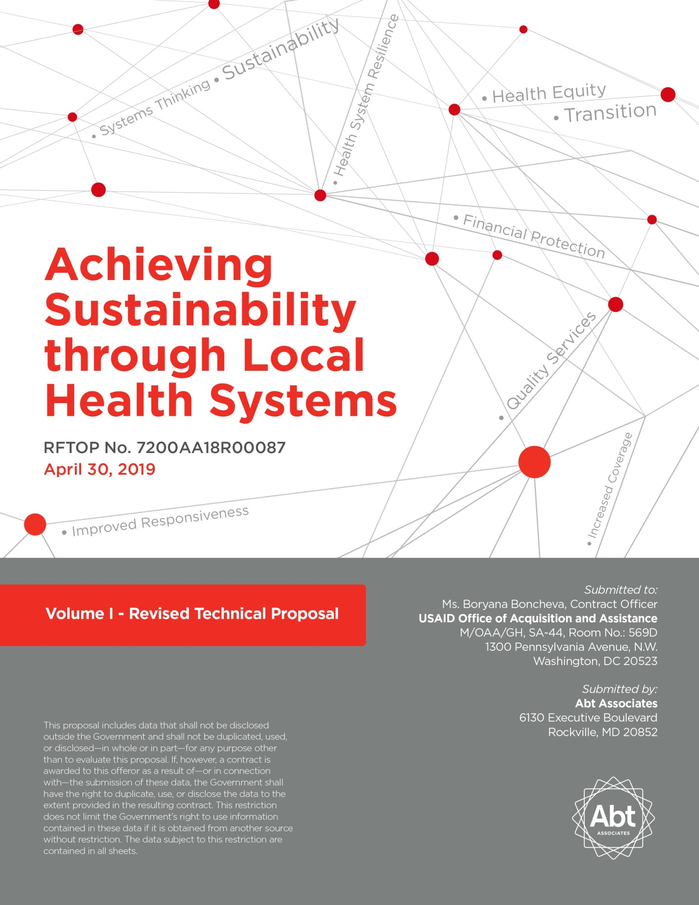

April 30, 2019

Attn: Boryana Boncheva, Contracting Officer  
U.S. Agency for International Development  
Office of Acquisition and Assistance, M/OAA/GH  
1300 Pennsylvania Ave., N.W., SA-44 Room No.: 569D

Washington D.C., 20523

**Re: Inclusion in the Competitive Range and Request for Revised Proposals under the Achieving Sustainability through Local Health Systems activity,   
Solicitation No. 7200AA18R00087**

Dear Ms. Boncheva,

Abt Associates (Abt), major subcontractors Save the Children (SC) and the Institute for Healthcare Improvement (IHI), and our entire consortium are pleased to submit our Revised Technical Proposal with changes highlighted in yellow for the Achieving Sustainability through Local Health Systems’ Request for Task Order Proposal (RFTOP). Our Response to Technical Issues is attached to this e-mail as a separate document. Our Cost/Business Proposal will be submitted in a separate set of e-mails.

Abt Associates’ proposal remains valid for 180 days from the submission date. If you have any questions during the period of evaluation of proposals or for negotiations leading to award, please address them to me at 301-634-1838 or by e-mail at Jay_Knott@abtassoc.com. You may also contact Peter Cole, Senior Contracts Administrator by telephone at 301‑347‑5159 or by e-mail at [Peter_Cole@abtassoc.com](mailto:Peter_Cole@abtassoc.com). Melissa B. Ashcraft, Abt’s Vice President for Contract Operations, is our authorized contract negotiation representative and can be reached at 301‑347‑5915 or by e‑mail at Lisa_Ashcraft@abtassoc.com. All parties listed above can be reached at the address of 6130 Executive Boulevard, Rockville MD 20852.

Thank you for your consideration. We look forward to hearing from you.

Sincerely,



Jay L. Knott, Chief Business Officer

CONTENTS

Acronym List iii

Executive Summary ES-i

1. Technical Approach 1

1.1. General Technical Approach for Ghana, Uganda and Dominican Republic 1

1.1.1 Employing Past and Emerging Learning to Address HSS Objectives 2

1.1.2 Sustainable Capacity Building and Local Partners 2

1.1.3 Grants Under Contract 3

1.1.4 Gender, Female Empowerment, and Social Inclusion 3

1.1.5 Leveraging the Power of Digital Solutions 4

1.1.6 Knowledge Management for Better Programming and HSS Learning 4

1.2. Detailed Technical Approach by Country 5

1.2.1 Ghana Technical Approach 5

1.2.2 Uganda Technical Approach 12

1.2.3 Dominican Republic Technical Approach 18

2. Key Personnel and Staffing 22

2.1. Key Personnel 22

2.1.1 Project Director Dr. Bob Fryatt 23

2.1.2 Technical Director Midori de Habich 24

2.1.3 MEL Specialist Dr. Ekpenyong Ekanem 24

2.2. Staffing Plan for All Staff 25

2.2.1 Staffing and Management Structure 25

2.2.2 Staff Qualifications 26

2.3. Roles and Responsibilities of Prime Contractor, Subcontractors, and Resource Organizations 27

3. Monitoring, Evaluation, and Learning Plan for Uganda 29

3.1. Theory of Change 29

3.2. Results Framework 30

3.3. Methods to Monitor Performance and System-Wide Effects and Changes 30

3.3.1 Approach to Utilizing and Strengthening Uganda’s Existing Routine Information Systems and Data 31

3.3.2 Data Quality Assessment Plans and Procedures 31

3.3.3 Methods to Measure and Monitor Local Partner Capacity 32

3.4. Collaboration, Learning, Adapting, and Knowledge Management 32

3.4.1 Project Monitoring and Adaptive Management for Learning 33

3.5. Single Evaluation Study Design 33

Annex 1: Illustrative Charts and Graphs A-1

Annex 2: Organizational Chart A-6

Annex 3: Key Personnel CVs/Resumes and Signed Statements of Commitment A-8

LIST OF EXHIBITS

Exhibit 1: The Abt Approach to Achieving Sustainability through Local Health Systems 1

Exhibit 2: Illustrative Approaches to Using Grants Under Contract 3

Exhibit 3: Digital Transformations to Reach Task Order Objectives 4

Exhibit 4: Selected Ways Ghana Activity 1 Addresses all Three Health System Dimensions 7

Exhibit 5: Selected Ways Ghana Activity 2 Addresses all Three Health System Dimensions 8

Exhibit 6: Selected Ways Ghana Activity 3 Addresses all Three Health System Dimensions 9

Exhibit 7: Selected Ways Ghana Activity 4 Addresses all Three Health System Dimensions 10

Exhibit 8: Selected Ways Ghana Activity 5 Addresses all Three Health System Dimensions 10

Exhibit 9: Transition to Local Partners in Ghana 11

Exhibit 10: Selected Ways Uganda Activity 1 Addresses all Three Health System Dimensions 14

Exhibit 11: Selected Ways Uganda Activity 2 Addresses all Three Health System Dimensions 15

Exhibit 12: Selected Ways Uganda Activity 3 Addresses all Three Health System Dimensions 16

Exhibit 13: Selected Ways Uganda Activity 4 Addresses all Three Health System Dimensions 17

Exhibit 14: Transition to Local Partners in Uganda 17

Exhibit 15: Selected Ways DR Activity 1 Addresses all Three Health System Dimensions 20

Exhibit 16: Selected Ways DR Activity 2 Addresses all Three Health Systems Dimensions 21

Exhibit 17: Transition to Local Partners in the Dominican Republic 22

Exhibit 18: Key Personnel—Exceeding Task Order Requirements 23

Exhibit 19: Abt Team Partner Roles, Responsibilities, and Lines of Authority 28

Exhibit 20: Theory of Change 29

Exhibit 21: Key Processes for Analyzing and Using Data for Learning and Adapting 33

Exhibit 22: Illustrative Evaluation Study Design that Integrates Complexity-Aware Methods 33

Exhibit 23: Abt Team Organizational Capacity Building Framework A-1

Exhibit 24: Monitoring Task Order Progress—Sample MandE Dashboard for Uganda A-1

Exhibit 25: Results Framework for Task Order Uganda Program A-2

Exhibit 26: Task Order Uganda Program Performance Indicator Tracking Table (PITT) A-3

Exhibit 27: Illustrative Examples of Abt Team Chiefs of Party A-4

Exhibit 28: Abt Team Matrix of Illustrative Staff Skills A-5

Exhibit 29: Abt Team Organizational Structure: Country-Led Implementation A-7

Acronym List

ASSIST Applying Science to Strengthen and Improve Systems

ATN Assistance Technique National

BMGF Bill and Melinda Gates Foundation

C/IMCI Community Integrated Management of Child Illness

CBHI Community-based health insurance

CDCS Country Development Cooperation Strategy

CHIM Centre for Health Information Management

CHPS Community-based Health Planning and Services

CHW Community Health Worker

CLA Collaborating, learning, and adapting

CMP Improvement Science in Action (Dominican Republic)

CNSS National Social Insurance Council (Dominican Republic)

COP Chief of Party

CQI Continuous quality improvement

DFAT Department of Foreign Affairs and Trade

DFID Department for International Development

DHIMS2 District Health Information Management System 2

DHIS2 District Health Information System 2

DQA Data Quality Assurance

DR Dominican Republic

DRM Domestic resource mobilization

GHED Global Health Expenditure Database

GHS Ghana Health Service

GODR Government of the Dominican Republic

GOU Government of Uganda

GPG Global Public Goods

GUCs Grants Under Contract

HANSHEP Harnessing non-state actors for better health for the poor

HeFRA Health Facilities Regulatory Agency

HFG Health Finance and Governance

HIS Health information system

HISP Health Information Systems Program

HMIS Health Management Information System

HRH Human resources for health

HSS Health systems strengthening

HSSA Health Systems Strengthening Accelerator

IHI Institute for Healthcare Improvement

HRHIS Human Resources for Health Information System

IP Implementing partner

IUP/ATN Integrated Use of Health Services/National Technical Assistance

JLN Joint Learning Network

KM Knowledge Management

LMIC Low- and middle-income countries

LMIS Logistics Management Information System

M&E Monitoring and Evaluation

MDG Millennium Development Goal

MEASURE Monitoring and Evaluation to Assess and Use Results

MEL Monitoring, evaluation, and learning

MELP Monitoring, Evaluation, and Learning Plan

MNCH Maternal, neonatal, and child health

MOF Ministry of Finance

MOH Ministry of Health

MPH Master’s in Public Health

MSP Ministry of Health (Dominican Republic)

NDOH National Department of Health (South Africa)

NHI National Health Insurance

NHQS National Healthcare Quality Strategy

NMCP National Malaria Control Programme

NQS National Quality Strategy

NQSSC National Quality Strategy Steering Committee

OCB Organizational capacity building

OOP Out-of-pocket

PAHO/WHO Pan-American Health Organization

PATHS2 Partnership for the Transformation of Health Systems 2

PEPFAR President's Emergency Plan for AIDS Relief

PFM Public financial management

PHC Primary health care

PITT Performance Indicator Tracking Table

PMTCT Prevention of Mother-to-Child Transmission

PPP Public-private partnership

QA Quality assurance

QI Quality Improvement

R4D Results for Development

RBF Results-based financing

RH Reproductive Health

RHITES Regional Health integration to Enhance Services

RMNCH Reproductive, Maternal, Neonatal, and Child Health

SARA Service Availability and Readiness Assessment

SaTI Sustainability and Transition Index

SBC Social and Behavior Change

SC Save the Children

SENASA National Health Insurance Authority (Dominican Republic)

SFS Family health insurance scheme (Dominican Republic)

SHOPS Strengthening Health Outcomes through the Private Sector

SMT Senior Management Team

SNS National Health Service (Dominican Republic)

SPA Service Provision Assessment

STTA Short-term technical assistance

TA Technical assistance

TAG Transition Advisory Group

ToC Theory of Change

TRG Training Resources Group

TWG Technical working group

UDS University for Development Studies

UHC Universal Health Coverage

VHT Village Health Team

ZAPIM Zimbabwe Assistance Program in Malaria

Executive Summary

***The last 20 years have seen a major evolution in health systems strengthening.*** Countries around the globe are striving for self-reliance as they work toward sustainable, resilient systems for delivering quality essential services that are accessible to all, including the poor and socially excluded groups. We now know more than ever about how to support their efforts. Simply achieving consensus across all low- and middle-income countries (LMICs) on the need for universal health coverage (UHC) has been a major breakthrough, as has the greater emphasis on primary health care (PHC) to improve health outcomes. These objectives cannot be met without improving accountability and adapting ***health financing*** so that individuals are protected from the high cost of health care and countries are able to mobilize, pool, and spend funds more effectively and efficiently. The objective of improving ***equity in access*** to essential services is more realizable today, thanks to a better understanding of the drivers of inequities and the efforts required to counter them. We also recognize that UHC will be meaningless without ***more attention to quality,*** so that access is more closely linked to improved health and survival.

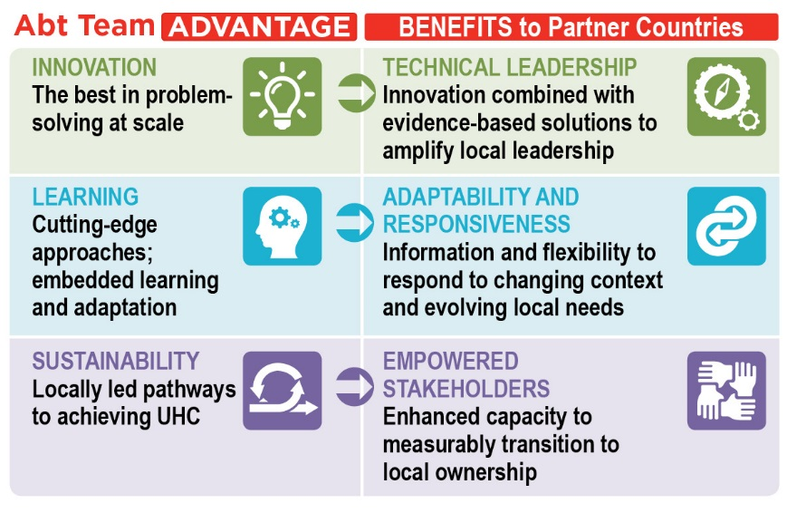***USAID has played a leading role in the health systems strengthening evolution.*** Now, through the Achieving Sustainability through Local Health Systems Task Order, the Agency will build on past successes while concurrently equipping countries to start transitioning away from donor support as they progressively meet their commitments to improving the health and well-being of their populations. Meeting USAID’s objectives will require a team experienced in working with local public and private sector counterparts to co-design solutions that address barriers to health system performance. It will also need a country-led implementation approach that accelerates progress toward UHC and establishes capacity to sustain that progress. ***Abt*** ***Associates*** has assembled the right team and approach to meet those needs.

***The Abt Team has long been at the vanguard of health systems innovation.*** Since 1989 ***Abt*** has worked with USAID and private and public sector stakeholders to modernize approaches for sustainable health financing and with WHO to reform health expenditure tracking. The ***Training Resources Group*** (TRG) has helped lead the move away from didactic training to the use of the latest science on adult learning and organizational effectiveness. ***Results for Development*** (R4D) has been at the cutting edge of global knowledge on strategic health purchasing and provider payment mechanisms and is leading USAID’s Health Systems Strengthening Accelerator (HSSA). These core partners, who were instrumental to the success of USAID’s Health Finance and Governance (HFG) project, are joined by innovators in other vital health systems strengthening (HSS) areas. Our team encompasses partners who have led the use of data to improve health systems performance, including the Health Information Systems Program (***HISP***) through its leadership on DHIS2. ***Save the Children*** (SC) has pioneered approaches in which providers and communities jointly define and improve service quality, accountability, and client satisfaction. The recent global focus on national leadership to 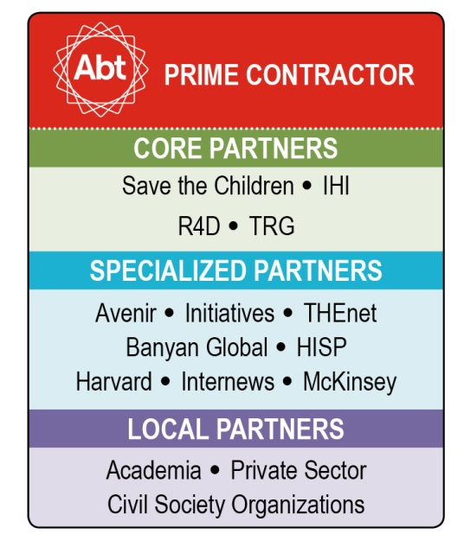sustain quality improvements has been led in part by the ***Institute for Healthcare Improvement*** (IHI), which has a long track record of being at the forefront of assistance to develop national quality strategies. These and other world-class specialized partners will work with local implementers from all sectors, retaining what has worked in the past while helping USAID remain at the leading edge of global HSS.

***We will spark a paradigm shift, enabling countries to achieve ambitious health goals independent of external support.*** Our starting point is a cycle of ***joint capacity assessment*** and ***co-design***, with local actors leading implementation. We will place a premium on monitoring, evaluation, and learning (MEL) to ensure that ***evidence-based decisions*** and ***adaptive management*** become mainstream. Efforts to incrementally strengthen core health system functions will accompany capacity building for local organizations to help them both perform and sustainably finance their health system functions. *G****ender equity***, female empowerment, and social inclusion will be reflected in all our work—because if women and vulnerable groups do not thrive, a country cannot deliver equitable access and achieve health impact. In short, we will support partner countries’ ***journeys toward self-reliance and improved health system performance***. Jointly with local partners we will capture, develop, and share knowledge, and with our partner R4D, facilitate the exchange of good practices and innovation across countries through participation in USAID’s HSSA and other forums.

***Our personnel have the technical depth and management expertise to help countries realize their UHC goals.*** Our key personnel offer USAID potent synergy built on years of collaboration under HFG. ***Project Director Dr. Bob Fryatt*** brings a proven ability to assist countries in moving away from donor dependence, both as HFG Project Director and in previous positions. In India and South Africa, for example, he advised on the UK Department for International Development (DFID)’s graduation and helped implement reforms that integrated priority programs such as HIV/AIDS into PHC. ***Technical Director Ms. Midori de Habich*** is a global HSS leader, former Minister of Health, technical expert, and experienced USAID COP. She Co-Chairs WHO’s UHC 2030 Technical Working Group (TWG) on "Sustainability and transition from external aid.” ***MEL Specialist Dr. Ekpenyong Ekanem*** worked closely with USAID’s Office for Health Systems to create the Health Systems Benchmarking Tool, a multi-sectoral indicator database used to compare system performance in over 60 countries. Our Key Personnel will oversee our team’s extensive pool of skilled, ready-to-deploy Chiefs of Party, country staff, and headquarters specialists, as well as our deep bench of more than 4,000 experts around the globe.

By the end of the Task Order, the Abt Team’s stewardship will ensure that every supported country has reached or exceeded its targets for ***increased financial protection, population coverage***, and ***coverage of quality essential services.*** Women and socially excluded groups willnot only have clearly improved health outcomes attributable to Task Order interventions, but will also be active participants in designing solutions that meet their needs. More than 50% of HSS work will have been transitioned to local organizations, and all supported countries will have in place long-term plans for reaching UHC independent of donor support. In short, we envision a world where people lead healthier, more productive lives thanks to stronger, more self-reliant health systems.

Our Vision for Success

# Technical Approach

In 2015, the leaders of Ghana, Uganda, and the Dominican Republic (DR) joined world leaders in committing to provide every individual in their countries—regardless of her or his ability to pay—with equitable access to a full range of promotive, preventive, curative, and rehabilitative essential health services as part of the Sustainable Development Goals. USAID has shown how to deliver on these commitments through its Vision for Health Systems Strengthening 2015–2019. The importance of these efforts is enhanced by evidence showing that stronger health systems make countries more resilient and better able to handle unexpected shocks, including major disease outbreaks that can destabilize regions and affect the global economy.

## General Technical Approach for Ghana, Uganda and Dominican Republic

The Abt Team is uniquely positioned to support countries on their journeys toward self-reliance and prosperity. We have repeatedly proven our ability to deliver results, no matter how difficult the situation. In addition, our team’s extensive global experience, knowledge of both public and private sector health systems, and long history of achieving HSS results has taught us the importance of co-assessing capacity and constraints, co-creating solutions, placing local leaders in the driver’s seat, monitoring progress, and using continual learning to adapt and respond to complex emerging needs. These principles are embedded in our approach to helping Task Order countries sustain health system performance and achieve impact (see Exhibit 1).

Exhibit 1: The Abt Approach to Achieving Sustainability through Local Health Systems

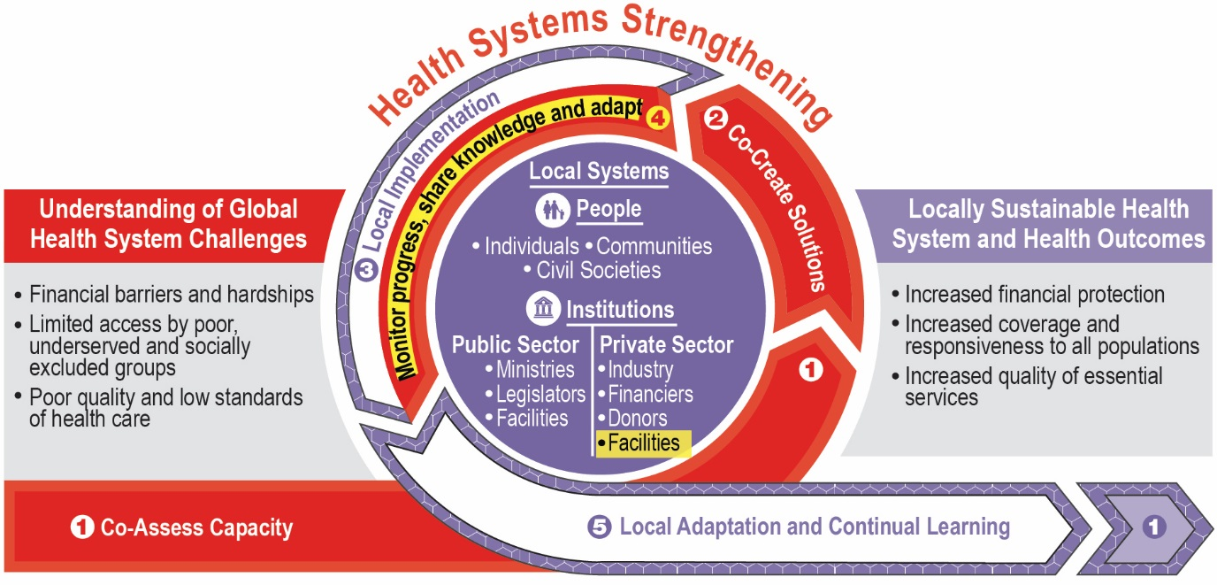

We will work side by side with local institutions from across sectors, supporting, mentoring and building their capacity to fulfill their roles in the health system so that activities can be transitioned to governments, civil society, and the private sector over the course of the Task Order. We will institutionalize adaptive management through the use of monitoring data and reflection points to improve or change approaches. Throughout we will use established tools, such as the Health Systems Assessment Approach and the Private Health Sector Assessment to encourage systems thinking, exploit synergies, and engage both the public and private sectors to help countries reach the three Task Order objectives.

### Employing Past and Emerging Learning to Address HSS Objectives

Our approach draws on the Abt Team’s extensive array of lessons and experiences from HFG and Sustaining Health Outcomes through the Private Sector (SHOPS) Plus, as well as these projects’ predecessors. It is also influenced by the cutting-edge work of our partners, such as the IHI and SC partnership in Bangladesh under the MaMoni Maternal and Newborn Care Strengthening Project and TRG’s work to systematize Collaborating, Learning, and Adapting (CLA) approaches for USAID’s work in Uganda and globally through the centrally funded Education Performance Improvement, Communications and Knowledge project.

***Objective 1: Increase financial protection.*** Health financing reform is both a political and a technical process that calls for specific attention to expanding coverage to poor and socially excluded groups and to ensuring the quality of services. We have learned that it is important to generate options for leaders while fostering inclusive, transparent decision-making.

***Objective 2: Increase population coverage.*** Removing inequities at scale requires political and financial commitment to delivering quality essential services to individuals in all communities. To ensure responsiveness to the needs of diverse beneficiaries, communities must be given a voice and reach must be expanded by deploying community health and clinical workers, engaging the private sector, and creating incentives for providers in underserved areas.

***Objective 3: Increase service coverage of quality essential services.*** Recent reports, such as the output of the 2018 Lancet Global Health Commission on High Quality Health Systems, have drawn attention to the need for a comprehensive approach to improving and sustaining service quality through national strategies that cover quality planning, quality improvement (QI), and quality control. Required changes include building effective governance structures and boosting the QI collaborative capability of frontline and community-based staff. New opportunities include linking financial reimbursements for providers (e.g. private sector and community workers) to verifiable quality targets and standards set by in-country regulatory authorities.

### Sustainable Capacity Building and Local Partners

To strengthen organizations vital to health systems in Ghana, Uganda, and the DR, we will build on the Abt Team’s substantial experience with institutional capacity building under HFG and SHOPS Plus, with continuing technical leadership from industry leader TRG. By the end of the project, organizations central to a functioning, growing health system will be self-sustaining entities. These may include ministry of health (MOH) operating units, sub-national levels of government, non-governmental organizations (NGOs), private providers, professional and private sector associations, academic institutions, social franchises, health insurance organizations, and distributors and sellers of priority health products.

***Identification of implementing partners.*** Our approach places local implementing partners (IPs) at the forefront of Task Order work. Members of our team—especially Abt, SC, IHI, HISP, R4D and THEnet—are already working with an extensive roster of IPs in the countries listed in RFTOP Attachment 1. In anticipation of this Task Order, Abt released calls for expressions of interest to support HSS in the three illustrative countries and received over 50 responses. Immediately upon start-up in each country, we will quickly vet applicants and further expand our database of IPs. In preparation for ***transition awards,*** we will begin by understanding national stakeholders’ vision and timetable for transitioning from donor support and external technical assistance (TA). This will guide joint decisions on the choice of IPs for transition awards, which will continue to provide TA and build capacity in priority HSS areas, with sustainable funding.

***Organizational capacity building approach***. Our organizational capacity building (OCB) approach is based on two-way partnerships and a vision of self-sustaining entities from across sectors. Our OCB focuses on performance, using baselines for planning and a range of interventions, including systematic follow-up, to drive improvements across three broad domains:

* ***Organizational development,*** including organization-wide efforts to increase effectiveness and accountability and achieve strategic goals.
* ***Technical capacity*,**including ability to provide quality health system support including TA, research, management and service delivery, and the ability to generate and use knowledge for adaptive approaches, especially as ownership increases and the scale of its work grows.
* ***Financial management, business planning, and compliance*,**including the systems needed to receive USAID and other donor funding and for the organization’s long-term viability, credibility, and protection of staff and clients (e.g., training in sexual abuse and exploitation).

The OCB Framework in Exhibit 23 in Annex 1 further defines these three areas and our approach to measuring capacity, which we will customize for each organization. We will ensure that IPs identified for transition awards are able to respond both to USAID’s stringent performance, contractual, and reporting requirements and to national government requirements (such as formal registration) for receiving external donor funding.

### Grants Under Contract

As shown in Exhibit 2, the Abt Team will deploy Grants Under Contract (GUCs) to achieve locally agreed objectives, encourage engagement with non-traditional partners (e.g., fledgling groups undertaking implementation research), build IP capacity, and foster innovative solutions. We will use a combination of In-Kind, Fixed Amount, Simplified and Standard grants, as appropriate and consistent with the administrative and financial capacity of each prospective Grantee and its ability to meet accountability and reporting requirements.

Exhibit 2: Illustrative Approaches to Using Grants Under Contract

| **Approach** | **Purpose and Methodology** |
| --- | --- |
| **Directed Grants** | For partners with insufficient capacity to receive subcontracts, such as fledgling groups undertaking research and private sector associations. Will include in-kind grants such as technical assistance to build the institutional capacity of governments and IPs to prepare them for USAID transition awards. |
| **Results-Based Grants** | To complement other funding sources and create incentives for better performance by providing additional funds to deliver additional results. Will build on performance-based funding experience. |
| **Umbrella Arrangements** | For organizations that fund and oversee networks of non-traditional partners that individually do not have the capacity to receive a grant. This could include, for example, groups working with people living with HIV/AIDS, injecting drug users, or men who have sex with men. Will enable grant funds to reach more beneficiaries and strengthen the leadership of the recipient group. |
| **Challenge Funds** | To call for innovative solutions to systemic problems, e.g., using new technology for maternal, neonatal, and child health services. Will include helping country leaders choose awardees; demonstrating proof of concept; assessing results; and determining eligibility for scale-up funding. |

### Gender, Female Empowerment, and Social Inclusion

The Abt Team will proactively integrate gender, female empowerment, and social inclusion into all phases of the project lifecycle, recognizing that these are development goals in their own right as well as accelerators toward achieving UHC. We will build on our past experience in areas such as championing women in key leadership, managerial, and technical roles; promoting equal pay; and incorporating socially excluded groups into governance mechanisms. At project start-up, our gender and social inclusion team, led by Banyan with field support from Abt and SC, will conduct a Task Order-wide gender and social inclusion analysis, laying the groundwork for a gender, female empowerment, and social inclusion analysis, strategy, and plan in each country. These plans will build on existing country analyses and initiatives to identify approaches to address gender bias and social exclusion for our work planning process. The plans will be part of the project’s MEL approach (see illustrative indicators, Exhibit 26 in Annex 1) and will transform gender and social norms among two groups: the partners we work with and health service beneficiaries. Gender, female empowerment, and social inclusion training will be mandatory for all project staff; we will adapt it for use with IPs. We will also identify champions within the MOH and civil society partners to foster local ownership of gender, female empowerment, and social inclusion efforts.

### Leveraging the Power of Digital Solutions

We see digital technology as a thread that can tie together the three HSS objectives, with a rising number of opportunities and solutions (see Exhibit 3). We will carefully identify and tailor digital technologies that enhance interventions, leveraging current donor investments where possible and including all sectors in the solution. Where existing technologies are in place, we will expand usability and scale to promote sustainability. Where new solutions are needed, we will pull from our team’s extensive database of vendors to help local stakeholders identify the most appropriate solutions and select the best options at the best price.

Exhibit 3: Digital Transformations to Reach Task Order Objectives

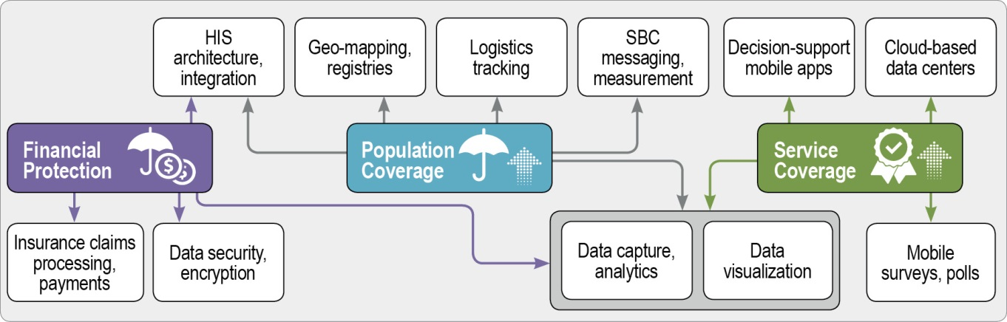

### Knowledge Management for Better Programming and HSS Learning

Our overall knowledge management (KM) approach is multifaceted and focused on ensuring that learning—including about innovations, successes, and challenges—is shared in appropriate formats and using strategic channels that support decisions and action. In alignment with CLA best practices, we will share successes and discuss failures as an opportunity to learn, and share learning with the broader community to inform future programming decisions. ***At the country level*,** we will share learning with a wide group of stakeholders and use “KM champions” to build a locally appropriate strategy and sustainable capacity. We will support central-level learning networks and participate in relevant TWGs (e.g., HSS, UHC, health financing), and explore sub-national and community level exchange opportunities where we work. ***At the Task Order level*,** we have an established mechanism that allows us to simultaneously monitor activities (see MandE in Uganda MEL Plan). In addition, we will use a *Sustainability and Transition Index* (SaTI) that will form part of a dashboard of indices (taken largely from existing databases) to assess progress across the three health system dimensions and countries, which we will synthesize into an annual report with country-specific sections and overarching analyses supported by Avenir for discussion with USAID’s HSSA. ***At the IDIQ and global level***, our Project Director (Bob Fryatt) and Technical Director (Midori de Habich) will ensure that knowledge gathered through our country work is captured and feeds into other Task Orders, as well as the global pursuit of optimal strategies to achieve UHC. This will be accomplished in close consultation with USAID and other actors including the WHO Global Learning Laboratory for Quality UHC, the Joint Learning Network (JLN) for UHC, and WHO-UHC 2030 sustainability and transition TWG, which Midori de Habich co-chairs. We will also synthesize technical experience and lessons through Learning Briefs, and other methods, similar to HFG. HSSA Liaison Amanda Folsom (R4D) will help coordinate KM across and beyond the two mechanisms, and facilitate continuous exchange and explore joint programming opportunities.

## Detailed Technical Approach by Country

The Abt Team’s proposed activities are designed to converge with other projects funded by USAID and other donors. Our strategy is to pursue ***fully integrated*** ***interventions—***each activity will contribute to multiple HSS objectives. To reflect this holistic approach, for each activity we include a table illustrating how selected activities contribute to results across the three objectives and highlighting the activity’s gender and social inclusion impact. Each country technical approach includes a table summarizing how the Abt Team will ***build local capacity to transition*** by ensuring that both traditional and non-traditional IPs from across sectors can assume responsibility for significant portions of HSS work.

### Ghana Technical Approach

To progress toward UHC and President Akufo-Addo’s goal of *Ghana beyond Aid*, Ghana must close gaps in health equity and quality of care. In 2017, the Ghana Health Service (GHS) noted that the Northern Region has seen the smallest reductions in poverty and the highest rates of under-five mortality, fertility, maternal mortality, and malaria fatalities. UNICEF reports that from 2006 to 2016 the gap between child mortality rates in wealthier and poorer regions doubled. The 2016 National Health Quality Strategy (NHQS) is designed to further a coordinated approach across sectors and institutions to increase access to quality respectful care. However, implementation is challenged by low population demand for quality care and uneven capacity of health institutions to fulfill their roles, such as the Health Facilities Regulatory Agency (HeFRA) and the Center for Health Information Management (CHIM). Ghana’s National Health Insurance Scheme (NHIS) has the potential to improve equity and quality, but the government has struggled to address design flaws that cause chronic deficits. This has resulted in coverage for only half the population and has led to delays in reimbursement of providers, which in turn reduces private providers’ incentives to participate and facilities using fees to sustain operations; as a result, household OOP is rising. Key actions identified by Ghana’s NHIS Technical Review Committee (2016-17) include: reforming the benefit package and provider payments; introducing more efficient patient care models; and reducing drug costs.

The Abt Team proposes a holistic approach that incorporates both the supply and demand for services. By co-designing and co-implementing with the MOH, GHS, NHI Agency, HeFRA, USAID/Ghana, and more than 10 IPs, we will leverage Ghana’s many strengths. These include existing strategies to increase demand, improve quality and equity, and strengthen the NHIS; public-private engagement on a large scale; local innovations; and objective and accurate media coverage through a free press and social media. Our team’s track record includes IHI’s successful Project Fives Alive! in Ghana—which reduced deaths of children under five by 35% across 146 hospitals—and its support for the launch of Ghana’s NHQS, as well as the NHIS review, which included reforms to strengthen Community-based Health Planning and Services (CHPS) PHC facilities. We draw on these and other experiences to propose interventions that will help MOH achieve the following health system objectives, which align with USAID’s extended Country Development Cooperation Strategy (CDCS) and Task Order goals:

* ***Increased access to integrated health services (CDCS IR 3.1) and availability of community-based health resources (CDCS IR 3.2).*** The MOH is expanding access to PHC by adding qualified health workers and CHPS facilities (the official national mechanism for reaching every community with a basic package of essential health services) in underserved areas such as those in the Northern, Upper West, and Upper East regions, as well as for poor and socially vulnerable groups (e.g., those most at risk for HIV). We will also work with GHS to effectively engage the private sector, provide grants to private providers to revitalize CHPS facilities, and support chemical sellers in rural areas at the community level.
* ***Strengthened and responsive health systems (CDCS IR 3.3)***. The MOH Quality Management Unit and the other 25 National Quality Strategy Steering Committee members, including other ministries, health agencies, provider groups, civil society representatives and others, will seek to implement the NHQS. The NHI Authority (NHIA) aims to introduce payment methods that reinforce providers’ compliance with QI and emerging accreditation standards. The NHIA will pursue reforms outlined in the 2016 HFG review to improve the NHIS’s financial sustainability and protect beneficiaries from out-of-pocket (OOP) expenditures. This includes revising the benefit package, linking provider payments to quality, and possibly increasing both earmarked funds to the NHIS and premium revenues, which currently account for only 3% of total NHIS revenue. The MOH intends to control drug prices and unnecessary drug use to reduce spending.
* ***Improved health sector governance and accountability (CDCS IR 3.4).*** The MOH will coordinate MEL activities conducted by the GHS, the NHIA, academic institutions, and donors to harmonize investments and ensure lessons are used to adapt interventions. MOH will establish Patient Protection Councils mandating the inclusion of women, vulnerable groups, and underserved communities to increase the responsiveness of the health system and its governance and accountability, and share data on quality and client feedback. Internews will strengthen the media’s capacity to give voice to underserved groups, report on and build understanding around health reforms, and share public expenditure information. GHS will deliver strategic communications in conjunction with the media on reforms.

We will engage local partners and CSOs who represent women and socially excluded groups, such as the Ghana Registered Midwives Association, the African Women’s Development Fund, and ACTION AID in our planning, and reference the gender assessment informing USAID’s upcoming CDCS if available, to ensure we proactively integrate gender, female empowerment, and social inclusion in our support.

#### Addressing the Three Health Systems Dimensions

**Ghana Activity 1:Support the MOH to implement the NHQS at all levels.** IHI, together with the Ubora Institute (which IHI helped establish), will provide technical assistance to help each health actor fulfill its role in implementing the NHQS:

* ***MOH.*** IHI and Ubora will assist MOH’s Quality Management Unit in supporting public and private provider organizations to establish quality management teams. These teams will identify quality gaps and embark on continuous quality improvement (CQI) activities and learning collaboratives, building on past lessons and focusing on the revised NHIS benefit package. This will include addressing negative attitudes and discriminatory practices by providers against women, men, and marginalized groups. Ubora will help MOH strengthen consumer engagement, including community health committees, with technology platforms (e.g., SMS, WhatsApp) where it makes sense, to involve clients directly in monitoring service quality. We will use these channels to disseminate results to local stakeholders and media to hold providers to account, promote adaptive management of programs, and ultimately improve service quality. IHI will help establish a gender-balanced “Patient Protection Council” to engage patient groups, especially marginalized communities, under the NHQS Patient Charter. Lastly, we will prepare HeFRA to fulfill its accrediting role.
* ***CSOs and private sector associations.*** We will include non-profit and private umbrella organizations in Ghana, such as the Christian Health Association of Ghana, Community Practice Pharmacists Association, in quality discussions and roll out of the NHQS quality***.***
* ***Training institutions.*** IHI, Ubora, and THEnet will help medical, nursing, and midwifery training institutions, including private sector schools, to integrate CQI and safety methods into curricula and service learning, as well as provider counseling to increase demand and raise awareness of patients’ rights to quality, respectful care.
* ***CHIM.*** HISP will help CHIM integrate QI data into the District Health Information Management System 2 (DHIMS2), and build capacity at levels indata capture and use to: 1) inform decisions about resource allocation and ensure resources are targeted to facilities and regions with the worst indicators or most inequitable outcomes, and 2) ensure health workers identify and address quality problems.
* ***Journalists.*** Internews will train and mentor journalists, especially female journalists who can accurately represent women’s views, to report on quality, build consumer understanding of the benefits of using appropriate services, and influence consumer choices around self-care (e.g. hand washing, healthy eating) and rational use of drugs.

The Abt teamwill also collaborate with the GHS Health Promotion Department (GHS/HPD), USAID’s Communicate for Health (C4H) project, providers, and communities to deliver tailored SBCC approaches***.*** In Year 1, Internews will conduct an Information Ecosystem Assessment to inform: 1) choices about content (e.g., about rights, services, and policies); and 2) formats and channels for dissemination (e.g., face-to-face, events, WhatsApp, social media, or local radio). Internews will work with C4H and GHS/HPD to ensure SBCC and education messages are communicated cohesively through the most effective, appropriate delivery mechanisms.

Exhibit 4: Selected Ways Ghana Activity 1 Addresses all Three Health System Dimensions

| **Obj. 1: Financial Protection** | **Obj. 2: Population Coverage** | **Obj. 3: Service Coverage** |
| --- | --- | --- |
| Reduced spending on unnecessary and poor quality care by changing provider practices and client expectations. | Population access to essential services will increase as the MOH becomes responsive to their needs and as growing numbers of communities are aware of and able to access essential services. | Patient satisfaction will increase as compliance to clinical protocols increases and service quality improves. |
| ***Gender and social inclusion impact.*** Female patients will receive more responsive, compassionate care and higher clinical quality as a result of NHQS implementation. Women and underserved community members will hold health actors accountable through representation on the Patient Protection Council. Women and other underserved communities will be better represented in the media. | | |

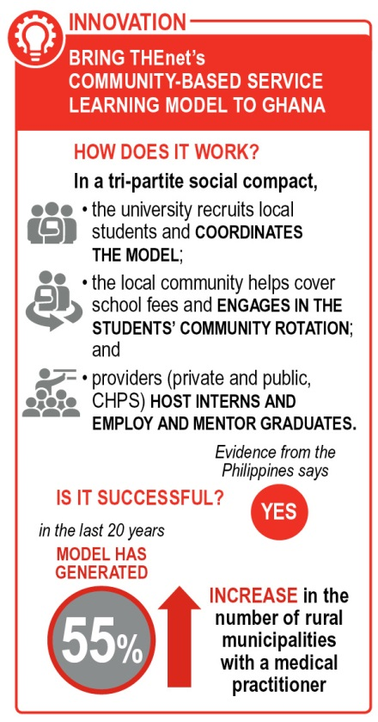**Ghana Activity 2:Help add and retain qualified health workers in underserved areas.** The inequitable distribution of health workers persists because they can refuse postings to hardship areas; lack adequate supervision; and have few options for professional development, especially options designed to retain female health workers. To complement national workforce development efforts, we will use THEnet’s community-based service learning model (see box), an innovative approach to closing HR gaps and improving retention. We will begin by working with the University for Development Studies (UDS), which has already started using this model in Northern Ghana, where inequalities are most pronounced. A full-time THEnet Coordinator and Ghanaian consultants will assist UDS and the Ghana Public Health Service to use national workforce data to: 1) optimize distribution of health workers through application of the WISN/POA tool, with a particular focus on increasing the number of male health workers at the primary and community level; 2) explore opportunities for partial scholarships and guaranteed positions for graduates; 3) expand the service learning model to community health workers, with attention to recruiting more female health workers; 4) align the model with Ghana’s NHQS to integrate delivery of the NHIS essential package and QI into curriculum and service rotations; and 5) conduct an impact evaluation of the number of health workers, their gender, rural rotations, service quality, and community-defined outcomes. By year 3, we will use lessons from the evaluation to replicate the model with the University for Health and Allied Services in Volta.

Exhibit 5: Selected Ways Ghana Activity 2 Addresses all Three Health System Dimensions

|  |  |  |
| --- | --- | --- |
| **Obj. 1: Financial Protection** | **Obj. 2: Population Coverage** | **Obj. 3: Service Coverage** |
| OOP spending (e.g., on unnecessary drugs) will fall due to an increased supply of qualified health workers (new and retained) in underserved areas. | Communities in underserved areas will enjoy increased access to services as the inequities are reduced in the distribution of qualified health workers. | Patients will benefit from higher quality PHC due to more frontline workers trained in QI techniques. |
| ***Gender and social inclusion impact.*** Patients, including underserved populations, will benefit from a more gender-balanced health workforce as a result of UDS recruitment efforts and from increased responsiveness to female and male patients’ needs. | | |

**Ghana Activity 3: Support NHIS financial sustainability.** To support implementation of the 2016 NHIS review mentioned above, the Abt Team will assist the NHIA to:

* Use the results of the USAID/Bill and Melinda Gates Foundation (BMGF)-funded NHIS actuarial study to revise the benefits package; emphasize PHC, including family planning; and respond to a gender analysis of the disease burden.
* Deepen the capacity of the NHIS Provider Payment Directorate to introduce provider payment systems that are harmonized across hospitals and PHC facilities, tie provider payments to delivery of the benefits package and quality through clinical protocols and rational drug use, and to reduce delays in claims processing (see box) while improving the detection of outliers and cost drivers.
* Engage the Ministry of Finance and parliament to 1) maintain tax funding that covers the poor; 2) support enrollment in NHIS at all levels of the health system (to overcome women’s difficulties in reaching enrollment offices); and 3) raise premium revenue (e.g., employer contributions).
* 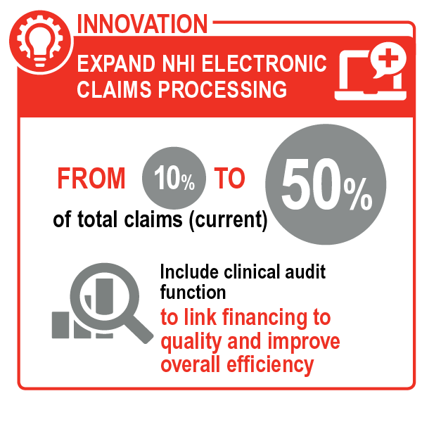Develop approaches with CSOs and other stakeholders to address gender barriers that suppress men’s enrollment in NHIS (50% of men compared to 70% of women are covered).
* Build the internal Research, Policy, and Monitoring and Evaluation Directorate’s capacity, using managerial dashboards and operations research, to monitor changes, improve external reporting, and use evidence for advocacy.
* Develop strategic communications to expand public understanding about the benefits of NHIS enrollment, targeting specific audiences (e.g., the poor, men, women) to increase the percentage of Ghanaians with NHIS coverage, and generate public/political pressure to augment funding for increased NHIS coverage and a constituency for reforms.

To complement the NHIA’s communications strategy, Internews will use a challenge fund to identify and train journalists open to accurate reporting on NHIS reforms through the use of storytelling and other techniques to drive attitude shifts on issues such as gender roles and rational use of drugs. Internews will work with existing media and new community, commercial, and digital media that are poised for take-off.

Exhibit 6: Selected Ways Ghana Activity 3 Addresses all Three Health System Dimensions

|  |  |  |
| --- | --- | --- |
| **Obj. 1: Financial Protection** | **Obj. 2: Population Coverage** | **Obj. 3: Service Coverage** |
| NHIS beneficiaries will be financially protected as the NHIS becomes more financially solvent and pays public and private providers on time so they do not charge fees to clients. | The percentage of Ghanaians with increased access to PHC services will increase as more providers link to NHIS as a reliable payer. | NHIS beneficiaries will have access to quality PHC services as the benefits package and new provider payment methods are aligned with the NHQS. |
| ***Gender and social inclusion impact.*** Female NHIS beneficiaries in a greater number of areas will access a benefits package that prioritizes PHC and FP, and reflects the gender-based disease burden. Women and men’s enrollment in NHIS will increase as the media conveys benefits and promotes men’s enrollment. | | |

**Ghana Activity 4: Push public and private providers to improve quality and efficiency.** A 2016 provider mapping by HFG revealed significant gaps in the delivery of PHC services, partly because many private providers are in solo practice and partly because they lack incentives to deliver preventive care. However, these are often the only service providers available in underserved areas. Furthermore, half of all NHIS payments are to private providers and most of them are unprepared to manage financially under fixed payment methods like capitation. To address these challenges on the payer side, R4D will assist the NHIA to introduce new fixed payment methods and issue provider contracts that encourage innovation. On the provider side, Abt’s local private sector expert and Banyan will work with professional associations, their members, CHPS facilities, and other providers to have solo doctors form networks (horizontal integration) and/or affiliate with hospitals (vertical integration), using the networks to:

* Introduce the full PHC package, with new preventive and other service offerings that make them eligible for capitation payments by the NHIA.
* Improve service quality, using quality as a requirement for participation, and offering members access to QI and professional growth opportunities, as well as CHPS facility revitalization grants
* Improve financial management so they can work successfully under fixed NHIS payments.
* Broaden and diversify leadership ranks to include more women, youth, and representatives of other disadvantaged groups, and support policies and administrative procedures that encourage training and commercial lending for female health facility owners.
* Help frontline health workers find additional financial and in-kind support to supplement their incomes and enhance their longer-term viability in low-income areas.

We will base our interventions on previous successes, such as Banyan’s collaboration with the Ghana Registered Midwives Association, GHS, and NHIS to revitalize private maternity homes, which led to a 50% increase in the use of maternal, neonatal, and child health (MNCH) services. Focusing particularly in underserved areas, we will use results-based grants (see Exhibit 2), and link private providers to commercial lenders to support the development of new and revitalized CHPS facilities that have the capacity to partner with GHS.

Exhibit 7: Selected Ways Ghana Activity 4 Addresses all Three Health System Dimensions

|  |  |  |
| --- | --- | --- |
| **Obj. 1: Financial Protection** | **Obj. 2: Population Coverage** | **Obj. 3: Service Coverage** |
| NHIS beneficiaries, especially the poor, will cease to be charged for services because providers will know how to successfully deliver the PHC benefit package under the new payment method. | Access to essential services in underserved areas will grow as more private providers and CHPS facilities offer the full PHC package. | The quality of PHC services will expand as providers establish professional peer review networks to review quality and better comply with clinical protocols. |
| ***Gender and social inclusion impact.*** Female health workers will be empowered by a stronger Ghana Registered Midwives Association and by increases in women’s roles as leaders in all professional associations. | | |

**Ghana Activity 5: Increase access to affordable quality drugs.** Drugs represent 50% of total NHIS costs and form a large part of household spending. Ghana’s 2017 National Medicines Policy addresses the causes of runaway drug prices, unnecessary use, and poor quality. We will use a locally recruited pharma expert to assist the MOH’s National Medicine Price Committee to: 1) regulate prices based on competition, market data, and affordability goals; 2) monitor the impact of its recent Framework Contracts for Essential Medicines tender to address prices that are persistently higher than international benchmarks; and 3) hold manufacturers, importers, and distributors accountable for lower prices in exchange for a waiver of the value-added tax to reduce household drug expenditure. Abt will work with the NHIA on payment policies, such as linking rational prescribing practices to reimbursement to ensure capitation payments only cover essential drugs, and establishing co-payments for brand-name drugs. To support the NHQS, Ubora will assist quality management teams to promote rational prescribing practices and disposal of expired and fake drugs. Building on previous successes, Banyan and Ghanaian organizations will explore ways for chemical sellers (especially those run by women) to provide access to prescription-only essential medicines; these are a major source of pharmaceuticals in rural areas. We will educate community committees about rational drug use as a critical aspect of quality, and raise public awareness about household drug use, improved prescribing, and transparency on pricing.

Exhibit 8: Selected Ways Ghana Activity 5 Addresses all Three Health System Dimensions

| **Obj. 1: Financial Protection** | **Obj. 2: Population Coverage** | **Obj. 3: Service Coverage** |
| --- | --- | --- |
| Patients and the NHIS will spend less on high-priced, poor-quality, unnecessary, and expired drugs as regulators monitor prices and quality. | Consumers in underserved areas will enjoy access to quality drugs as licensed chemical sellers gain accreditation and access to legitimate lower priced drugs. | Quality essential drugs will be more available due to more rational prescribing practices and the disposal of fake and expired drugs. |
| ***Gender and social inclusion impact.*** Women, regardless of NHIS coverage, will benefit from a consistent supply of lower-priced, quality medicines. Female chemical sellers will have chances to participate in interventions to sustain their businesses. | | |

#### Capacity Building of IPs to Prepare for Transition

The Abt Team has identified local IPs in Ghana and envisioned their project roles, the types of capacity building they need, and their role post-project. Exhibit 9 shows potential IPs in Ghana that we have reached out to, including local institutes, community organizations, public and private service providers and associations, and local media partners. We will use our OCB framework to transfer knowledge and build capacity (see Section 1.1.2 and Exhibit 23). Column 2 summarizes the IPs’ roles (both in the health system in general and under the Task Order), while column 3 lists the types of support we will provide to maximize their capacity during Years 1–3. Column 4 shows our expectations for the partners’ transition status during Years 4–5, to enable them to undertake up to 50% of country work by the end of the Task Order.

Exhibit 9: Transition to Local Partners in Ghana

| **Illustrative Local Partners** | **Illustrative Local Partner Roles in HSS and under Task Order** | **Task Order Role**  **Years 1–3: Capacity Building** | **Partner Status**  **Years 3–5: Transition** |
| --- | --- | --- | --- |
| Ubora Institute (via IHI) | Deliver TA to MOH, service providers, regulatory agencies, and professional associations to implement NHQS (Activities 1, 4) | Expand capacity to deliver TA (through IHI subcontract) | Have in-country funding for TA practice to meet local demand from providers and government |
| Associations (Ghana Registered Midwives Association, Community Practice Pharmacists Association, etc.) | Assist public and private providers to  institutionalize roles in NHQS; Engage in community-based service learning model and rational pharma; Form/strengthen networks to offer full PHC packages and adopt managed care (Activities 1, 2, 3, 4, 5) | Strengthen institutional capacity and add value to members by building ability to make and execute business plans, provide TA to members, and raise revenue (through subcontracts and TA from Abt, Banyan, IHI) | Have growing TA practice with members and payers;  Experience revenue growth;  Be recognized as active partners with MOH to implement national quality and NHI reforms |
| Public and private health service providers (Christian Health Association of Ghana, other faith-based organizations); GHS | Provide high-quality PHC (Activities 1, 2, 4); Integrate QI into patient care; expand use of DHIMS2 and e-records; Engage in community-based service learning model; Adopt managed care methods to succeed under fixed payment system (Activity 4) | Support investments in staff capacity, internal systems, and infrastructure (through in-kind GUCs, funds to private providers, TA to public providers such as GHS) | Have institutionalized CQI;  Be accredited by HeFRA;  Hold long-term contracts with UDS and other academic institutions |
| Eligible private providers and/or community organizations; GHS | Create new/revitalize existing CHPS facilities through public-private partnerships with GHS; Participate (CHPS) in community-based service learning model (Activities 2, 4) | Mobilize private resources (through results-based GUCs and commercial banks) to invest in CHPS facilities, to allow them to contract with and provide TA to GHS | Operate independently with GHS co-funding recurrent costs;  Receive direct donor funding (private organizations) |
| UDS; University for Health and Allied Services | Maintain and expand community-based service learning model to new districts to add, retain, and train health workers in underserved areas (Activity 2) | Build UDS and private academic institutions’ organizational and technical capacity (through GUCs and TA from THEnet) | Operate self-sustaining practices through contracts with providers (employers), community, and tuition revenue |
| Ghana Pharmacy Council; Pharmaceutical Society of Ghana | Support licensed chemical sellers to expand access to essential medicines at lower prices (Activity 5) | Build organizational and technical capacity to support licensed chemical sellers to partner with facilities (through GUCs) | Have business plans to sustain solutions, such as partnerships with facilities |
| Local journalists (Internews Fellows); community, digital, commercial media | Communicate complex policy changes and messages to transform attitudes about gender, healthy behaviors, quality (Activities 1, 3, 5) | Build technical capacity in journalism through a challenge fund (with TA from Internews) | Continue using skills to affect public attitudes and behaviors |
| MOH; University of Ghana | Engage in evaluation, implementation research, and collaborative learning (Activity 6) | Build capacity to design and conduct research (subcontract to University of Ghana) | Lead research independently |

#### Learning and Adaptation

Our Ghana-based MEL Specialists will work with MOH and public and private sector stakeholders to co-design M&E methods, review evidence generated through the project, and lead forums for joint learning and adaption. M&E measures could include monitoring NHQS roll-out by using DHISM2 data from health facilities in 216 districts and adding a health expenditure module to the next Living Standards Survey to measure catastrophic household health spending. Harvard and the University of Ghana will co-design a mixed methods evaluation of Activity 2 using DHIMS2, Human Resources for Health Information System (iHRIS) for health workers, and the Multiple Cluster Indicator Survey of health impact. “Reflect and Refocus” sessions will share learnings and provide the space to collectively determine how these lessons should be applied, the processes and tools that need to be adapted, and establish roles and responsibilities going forward. The Abt Team will identify a KM lead to champion knowledge sharing and application both during the project and after it ends. These actions combined will accelerate the KM, CLA, and M&E capabilities of our local IP partners.

### Uganda Technical Approach

Uganda has made commendable efforts to define its vision and strategy for achieving UHC, but challenges remain. Recent corruption scandals involving the government’s misuse of funds from Gavi, the Global Fund, and USAID have reversed the progress achieved through Uganda’s Sector Wide Approach and created mistrust of the government by donors and the general public. Households still face significant financial barriers to access services that should be free. Long distances continue to limit services access in areas such as northern Uganda, which is also home to a substantial refugee population. On the positive side, the MOH and a vibrant civil society bring a wealth of experience and commitment to quality improvement, results-based financing (RBF), voucher programs such as the Abt-managed Voucher Plus project, and community-based health insurance (CBHI). We will work with MOH, NHIA, National and Joint Medical Stores, the private sector, and at least five local IPs to target entrenched problems. We will build MOH credibility, improving its capacity and mobilizing civil society and private sector groups to jointly establish a feasible pathway to achieve three of Uganda’s UHC goals:

* ***Increase domestic financing for health.*** Government of Uganda (GOU) spending on health is far lower than the WHO-recommended 30%, with an unsustainable level of resources coming from donors (41%) and households (40%). At the same time, inefficiencies—including provider absenteeism, leakage of PHC grants, and drug leakages—exacerbate low levels of funding and hinder the ability of MOH to effectively advocate for more resources. The Abt Team will use a two-pronged approach: 1) increase efficiency of health spending to free up resources, and 2) use evidence to advocate for more government investment in health.
* ***Strengthen national expertise and leadership to achieve financial protection for all Ugandans.*** Although the government has committed to providing health care to its citizens free of charge, OOP spending is very high; this is prohibitive and potentially catastrophic for many Ugandans. The government has made great strides in defining its National Health Insurance Scheme (NHIS), but needs to finalize the proposed benefits package, identify premium rates and which groups need subsidies, support capacity building of the NHIS Secretariat to enhance knowledge and skills in health financing, and package information for sensitization, advocacy, and lobbying to ensure support for NHIS reforms at all levels. We will strengthen core MOH functions to increase financial protection.
* ***Improve the availability and quality of public and private sector services*.** The private sector provides around 60% of health services in Uganda, but services are not standardized, while quality of care in the public sector is suboptimal. Governance, accountability, and supportive supervision mechanisms are not functioning effectively—Regional Referral Hospitals are mandated to oversee lower level facilities but are understaffed and under budgeted. Quality challenges persist at the community level. A strategic objective in Uganda’s QI Framework and Strategic Plan is to “strengthen involvement of clients and community” in improving quality. Inclusive participation and community access to information/services is also a sub IR (3.2) in USAID’s Uganda CDCS 2016-2021. We will support the MOH to identify successful facility-based QI efforts and lessons that can be scaled up, using financing initiatives to ensure that scarce resources are used to purchase quality services.

We will build on findings from the 2018 USAID *Gender and Social Inclusion Analysis for Uganda* and consult with GOU and local stakeholders, including the Civil Society Budget Advocacy Group and Straight Talk Foundation to identify gender and social exclusion factors that prevent marginalized populations from accessing services, in addition to health system-based factors that limit access to services by some socially excluded groups.

#### Addressing the Three Dimensions of UHC

**Uganda Activity 1: Strengthen public financial management (PFM).** Improved PFM will rebuild MOH credibility to advocate for resources. It will also address inefficiencies (poor management practices, problems with drug procurement and use, corruption). We will help MOH:

* ***Better manage domestic funds.*** To help the MOH demonstrate accountability and transparency so that it can enhance its credibility and advocate for more public and donor resources to deliver free public services and increase health worker availability. Abt will lead capacity building for MOH to expand and strengthen the links between needs-based planning, program-based budgeting, and expenditure tracking. This will ensure the right amounts are allocated to facilities to cover the true costs of delivering services, including for staffing. Abt will also support MOH to conduct costing analyses to identify misallocated or wasted resources. We will help GOU improve facility-level resource management and strengthen resource allocation processes, as Abt is successfully doing under the Tanzania Public Sector Systems Strengthening Project and did in Ethiopia under HFG.
* ***Address community needs.*** SC will support the Civil Society Budget Advocacy Group to increase community involvement in planning and budgeting, including through innovative technology solutions implemented elsewhere by HISP (see box). Higher-quality services will result as communities see their priorities better reflected in the work of health facilities. SC 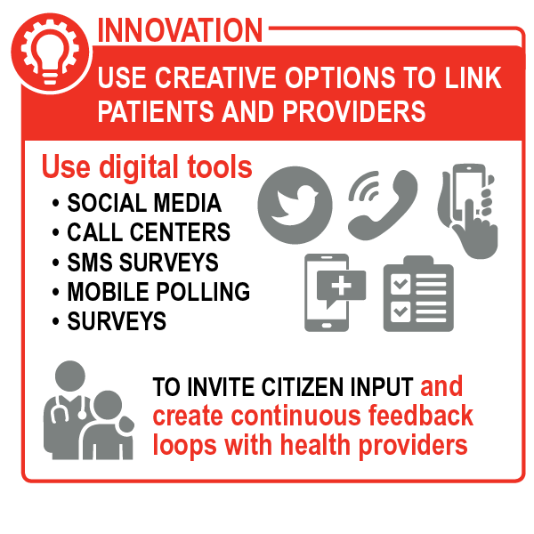will encourage communities to demand better services, focusing on female and other marginalized groups, and Abt will work with community groups to address structural barriers that further marginalize or constrain access. For example, we will support GOU to operationalize the 2015 PFM Act that mandates ministries and agencies present a Certificate of Gender and Equity compliance from the Equal Opportunities Commission before parliamentary approval of plans, policies, and budgets
* ***Rationalize drug spending.*** Lack of availability of some drugs in public facilities and the sale of others that should be free both contribute to high OOP spending. Abt will address inefficiencies in pharmaceutical procurement to reduce stock-outs and ensure the availability of drugs in facilities. Building on the experiences of the Uganda Health Supply Chain project and Medical Access Uganda, we will reduce leakage and assist health facilities and National and Joint Medical Stores to: 1) improve forecasting, distribution, and warehousing/storage; 2) negotiate better commodity prices; 3) link stores’ payments to performance (see Uganda Activity 2), as Abt did in Mozambique under the Health Systems 20/20 project; and 4) look for new ways to engage the private sector in strengthening the supply chain.

Exhibit 10: Selected Ways Uganda Activity 1 Addresses all Three Health System Dimensions

|  |  |  |
| --- | --- | --- |
| **Obj. 1: Financial Protection** | **Obj. 2: Population Coverage** | **Obj. 3: Service Coverage** |
| Free public health service availability will increase and household OOP payments for free services will decrease, thanks to more efficient health spending. | More people will benefit from responsive services and lower cost drugs as a result of improved efficiency and accountability mechanisms | Inputs needed to provide quality services will be increasingly available due to fewer drug stock-outs and increased availability of health workers. |
| ***Gender and social inclusion impact.*** Women and children will gain from increased female engagement in oversight of facilities and from more reliable availability of commodities for sexual, reproductive, and MNCH services. | | |

**Uganda Activity 2: Build foundational capacity and a pathway for increased financial protection.** Despite some progress toward NHI, such as the Certificate of Financial Implications that clears the Ministry of Finance to present the NHI bill to Parliament, many questions and doubts persist among private employers, providers, and the general public. How will the poor be targeted and subsidized? What is the best way to reimburse providers? How will costs be managed? To equip the MOH and the NHI Task Force to implement the NHI, R4D will lead our team in assisting the MOH to take practical steps that will build competence in benefit package design, actuarial analysis-based planning, provider contracting, strategic purchasing, and targeting. We will:

* 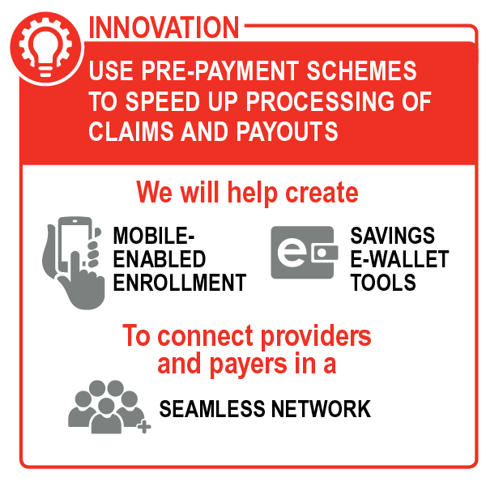***Expand coverage of the informal sector.*** Uganda’s voucher programs and CBHI market offer opportunities to cover low-income workers in the informal sector, who account for more than 75% of the labor force. R4D will help define longer-term strategies and mechanisms for pooling the financial and management resources of Uganda’s 100+ community health financing schemes and voucher schemes, working closely with local organizations such as Save for Health. We will explore the use of technology to make enrollment easier for CBHI members and ensure prompt payment to providers (see box). We will incorporate more strategic purchasing of health services, using Ugandan and global experiences with RBF, capitation, and diagnosis-related groups. This will help motivate providers who participate in CBHI to deliver services that meet the government’s minimum quality standards. We will help define and implement an affordable benefits package that will benefit all pre-payment scheme members and avoid different benefits packages across different schemes, which can exacerbate inequalities.
* ***Provide women and socially marginalized groups with a greater voice in shaping the future of NHI.*** We will support the development of a common understanding of NHI. Using tools such as the HFG/JLN Practical Guide for Strategic Communication, we will help the MOH and civil society groups use strategic communication to create consensus around UHC and NHI and increase enrollment in CBHI schemes. Internews will integrate lessons from its media education under the former Saving Newborn Lives 3 project and USAID’s Social Advocacy project to train the media to accurately report on UHC. We will ensure that communication efforts target organizations that support women and underserved groups.
* ***Improve coordination and stakeholder engagement.*** With support from TRG, SC will train and mentor the MOH to increase the quality of its dialogue with national- and subnational-level civil society and private sector stakeholders. This will build consensus on health system challenges, roles, and actions and will help rebuild trust. SC will support Ugandan organizations such as the Straight Talk Foundation to strengthen engagement with political and religious leaders, Village Health Teams (VHTs), community health workers, and other community leaders to bring them into discussions on CBHI, voucher schemes, and NHI. We will also support the Uganda Health Care Federation to conduct public-private forums with health sector actors to improve service quality and accessibility, using the evidence from M&E as the basis for learning and adaptation.

Exhibit 11: Selected Ways Uganda Activity 2 Addresses all Three Health System Dimensions

|  |  |  |
| --- | --- | --- |
| **Obj. 1: Financial Protection** | **Obj. 2: Population Coverage** | **Obj. 3: Service Coverage** |
| Financial protection for formal and informal sector workers will increase as the government’s move toward NHI accelerates (via expansion of CBHI schemes). | The number of Ugandans who can access care will increase as key groups (e.g., informal sector, women) are targeted for the expansion of financial protection schemes. | A minimum package of integrated, quality services will be guaranteed to those who enroll in CBHI, in contrast to the current patchwork of services. |
| ***Gender and social inclusion impact.*** Women, who are often responsible for seeking care for children, will benefit from CBHI and RBF and from vouchers that will be especially targeted to their needs and the needs of their children. | | |

**Uganda Activity 3: Support a comprehensive country-wide system for CQI of health services.** The MOH is committed to improving service quality, as shown by its Quality Improvement Framework and Strategic Plan. However, QI is not yet institutionalized and efforts have been focused at the facility level. To resolve previous fragmented efforts, we will collaborate broadly to tackle the problem at both the national and community levels. IHI will lead efforts to support MOH to learn from and scale up existing successful QI efforts and work with SC to expand into community health systems. We will link supply and demand elements of quality through CQI cycles covering all levels of the health system.

* ***Establish CQI at the national level.*** IHI will facilitate collaboration with ongoing USAID efforts—including Regional Health Integration to Enhance Services (RHITES), Advocacy for Better Health, and the forthcoming Uganda Health System Strengthening project—to identify positive experiences of QI in public and private facilities. We will facilitate scale-up and support MOH to incorporate those practices into the national QI strategy. IHI will work with R4D (see Uganda Activity 2) to advise MOH on how to tie providers’ participation in pre-payment schemes to achievement of quality standards.
* ***Establish CQI at the community level.*** Supported by IHI and Initiatives, SC will help strengthen the community-level CQI feedback-reporting loop, using its Partnership-Defined Quality scorecard approaches, which are in line with the National Quality Improvement Framework and Strategic Plan. These include standards for respectful and confidential care and services for women, people living with disabilities, and other marginalized groups. We will share guidelines with private providers and facilitate their CQI role. Our team will help MOH adapt its Guide to Quality Improvement Committees into a user-friendly tool suitable for the community level. HISP will guide work with facilities and communities to analyze and interpret feedback that leads to action that improves quality. Under the lead of SC, HISP will strengthen existing supervision tools that streamline the quality assessment process, generate comparative data, and guide action plans and accountability. SC will explore replicating the QI regional learning network developed by the Saving Newborn Lives 3 project in the Hoima Region to encourage real-time peer-to-peer and adaptive learning.

Exhibit 12: Selected Ways Uganda Activity 3 Addresses all Three Health System Dimensions

| **Obj. 1: Financial Protection** | **Obj. 2: Population Coverage** | **Obj. 3: Service Coverage** |
| --- | --- | --- |
| Households will not need to seek care elsewhere and pay out of pocket, due to improved service quality in the public sector. | More users—including women, youth, and the poorest—will be willing to seek care through more effective community health systems. | Health facilities and district health teams will be able to provide quality essential services on a sustainable basis, thanks to a comprehensive QI process. |
| ***Gender and social inclusion impact.*** Women will more frequently access maternal, sexual, and reproductive care because quality will improve. | | |

**Uganda Activity 4: Increase coverage of essential services by maximizing the comparative advantages of public and private providers.** Uganda will need to use the strengths of all actors in the public and private sectors, including faith-based organizations (FBOs) and community-level institutions, to improve equitable access to health services. Private sector providers already provide 60% of health services in Uganda and have the potential to relieve over-burdened public facilities. Abt will work with the GOU to use the non-public sector to increase the availability of health services, drawing on our wealth of knowledge from the SHOPS and SHOPS Plus projects.

* ***Engage the private sector to increase access to care.*** Using a Total Market Approach, Abt will help develop viable partnerships to improve the quality and affordability of services. In the near term, we will work with MOH to develop mechanisms to obtain laboratory and diagnostics services from FBOs already present in hard-to-reach areas⎯the Ugandan Protestant, Catholic, and Muslim Medical Bureaus. We will also help MOH advocate to focus existing private not-for-profit financial outlays on at-risk districts with large numbers of refugees. In the longer term, we will work with MOH and Ministry of Finance, Planning, and Economic Development to develop mechanisms under NHIS that involve the private sector. Building on our work under the USAID-funded Private Sector Project One and Banking on Health projects in Uganda, we will also recommend greater engagement with professional midwives. The Abt team will work with umbrella organizations (e.g., the Private Sector Foundation of Uganda and the Uganda Private Midwives’ Association) to encourage private providers to participate in CBHIs. We will also seek to welcome for-profit, NGO and FBO providers into financing schemes with incentives to operate in underserved areas.
* ***Pilot community-based service learning*** ***to increase human resources for health (HRH).*** To increase and retain health workers in regions with large HRH gaps (e.g., Northern Uganda and Karamoja), THEnet and Mbarara University of Science and Technology will pilot socially accountable medical education (see THEnet’s community-based service learning model described in Ghana technical approach). They will recruit students from underserved areas, providing scholarships and internships to help them apply their training in their own communities. THEnet and Mbarara will also use tools such as USAID’s CHW Coverage and Capacity Tool to support a more effective and efficient distribution of tasks between CHWs and VHTs. Our support for recruitment, training, and supervision of CHWs/VHTs will encourage positive attitudes toward patients.
* ***Support the effective deployment of VHTs in hard-to-reach areas***. Despite structural challenges that are being addressed by the GOU, VHTs continue to play a critical role in providing information and services such as iCCM in underserved areas. We will help MOH allocate VHT tasks using evidence on best practices, ensure VHTs receive supportive supervision from the public sector, and are effectively engaged through strengthened referral practices.
* 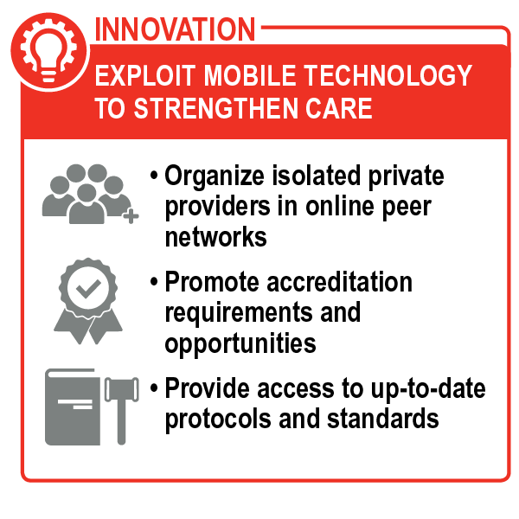***Deploy media to strengthen networking and learning among private and community-level providers.*** Internews will use Internet-based (e.g., WhatsApp group) tools to: 1) keep CHWs, private providers, and other communities of practice connected; and 2) deliver small bursts of distance-based learning tailored to fill skills gaps (as identified during QI activities) as part of the growing use of technology to strengthen community health systems (see box).

Exhibit 13: Selected Ways Uganda Activity 4 Addresses all Three Health System Dimensions

| **Obj. 1: Financial Protection** | **Obj. 2: Population Coverage** | **Obj. 3: Service Coverage** |
| --- | --- | --- |
| The GOU’s free health care policy will be more effective and households will not need to pay for basic services because government-financed health services will become more widely available. | An increased proportion of the population will have access to health services thanks to more coordination between the public and private sectors. | The population will have access to quality essential services due to greater engagement of non-state media and coordination of public and private providers. |
| ***Gender and social inclusion impact.*** Communities will benefit from greater access to services by women-owned private providers, whose increased access to credit will enable them to expand their reach. | | |

#### Capacity Building for Transition

Uganda already benefits from a vibrant civil society in the health sector, including IPs we have pre-identified and listed in Exhibit 14 (laid out as described in the Ghana technical approach). For example, we will support the Private Sector Foundation of Uganda and Uganda Health Care Federation to increase private sector service delivery through insurance enrollment and building their capacity to help providers increase access to credit and roll out minimum quality standards through strategic purchasing; this will lead to partnerships with MOH by the end of the project.

Exhibit 14: Transition to Local Partners in Uganda

| **Illustrative Local Partners** | **Illustrative Local Partner Roles in HSS and under Task Order** | **Task Order Role**  **Years 1–4: Capacity Building** | **Partner Status**  **Years 3–5: Transition** |
| --- | --- | --- | --- |
| Civil Society Budget Advocacy Group | Engage citizens in budget allocation, expenditure, and use (Activity 1) | Strengthen organizational and technical capacity (Years 1 and 2) (through TA from SC); Build technical capacity in advocacy (Years 3 and 4) (through GUCs and quality assurance (QA) from SC) | Receive GUCs and USAID transition awards to lead citizen engagement |
| Straight Talk Foundation | Mobilize political and religious leaders, VHTs, and others at the community level to engage in UHC advocacy (Activity 3) | Strengthen organizational and technical capacity (Years 1 and 2) (through TA from SC); Build technical capacity for TA in citizen engagement (Years 3 and 4) (though GUCs and QA from SC) | Receive GUCs and USAID transition awards for self-sustaining TA practice in advocacy |
| Save for Health Uganda | Explore options to expand CBHI coverage and maintain financial viability of schemes (Activity 3) | Build capacity to advocate for 1) local leaders to increase CBHI enrollment, and 2) a MOH/NHI Task Force to explore strategies and mechanisms to optimize existing insurance and voucher schemes (through QA from Abt) | Prepare for direct contracts from GOU to generate (and help MOH interpret) evidence for pooling CBHIs into NHI |
| Private Sector Foundation of Uganda; Uganda Health Care Federation | Engage private sector in service delivery and insurance enrollment; Build capacity of private providers (Activities 3, 4, 5) | Build technical capacity to 1) help private health providers participate in CBHIs and increase access to credit; and 2) roll out and enforce minimum quality standards through strategic purchasing mechanisms (through results-based GUCs and QA from IHI) | Lead development of PPPs with MOH  Support institutionalization of CQI among members |
| Mbarara University of Science and Technology | Promote socially accountable education in underserved areas (Activity 5) Potential KM champion | Build capacity to pilot socially accountable education (through QA and TA from THEnet) | Prepare for direct GOU contracts to recruit, train, and place health workers in underserved regions |

#### Learning and Adaptation

The Abt Team will support MOH coordination of in-country initiatives ensuring inclusion of key non-state actors. This will involve, for example, working closely with the European Union’s Supporting Policy Engagement for Evidence-Based Decision Making partnership and the anticipated Uganda Health System Strengthening program, to use health system data todesign, implement, track, and improvenational initiatives. SC will support CHW/VHTs by adapting the regional learning network approach, from which others can learn. All Abt Team partners will help the MOH incorporate a process for action-learning into existing annual events. Regular monitoring will help inform further development of the SaTI and foster shared accountability by giving all types of stakeholders opportunities to share experiences and lessons and obtain feedback to inform next steps. For more details on learning and adaptation in Uganda, see Section, Uganda MEL Plan. We will use “reflect and refocus” sessions with local partners to review evidence and determine how lessons should be applied, potential adaptations, and roles and responsibilities going forward. We will designate a KM lead from among local partners to champion KM during and after the project.

### Dominican Republic Technical Approach

Despite years of strong economic growth, the Dominican health system falls behind its peers in terms of absolute government expenditure on health. In addition, the DR has made slow progress developing a family health insurance scheme (SFS). This scheme features a single benefits package; a subsidized regime for the poor under a new national health insurer (SENASA); a contributory regime for employees insured by private insurers; and the National Health Service (SNS), which is responsible for managing public health providers. The DR continues to struggle to guarantee access to affordable, quality health services; spend resources efficiently; and collect pre-paid contributions to health from private businesses, the government, and employees. A consequence of this is the high rate of OOP spending by patients, especially on medicines and supplies. This expenditure is likely borne by individuals not enrolled in insurance, as well as those enrolled who have reached their annual limit for medicines (approximately US $160). These expenditures are also the result of co-payments for services provided in the contributive regime, unauthorized side payments to service providers, and payment for services not included in the insurance benefit package. As a result, although the DR has had one of the highest rates of GDP growth in the Latin America and Caribbean Region since the 1990s, improvements in health indicators are slower than elsewhere. The consequences of poor insurance coverage are exacerbated by poor quality PHC, poor quality care in under-funded hospitals (due to in part to insufficient payment systems), and insufficient access to services not in the basic package.

The Abt Team has a deep understanding of the DR’s health system through nearly two decades of supporting USAID on the *RedSalud*, *RedSalud II*, Maternal & Child Centers of Excellence, HFG, and SHOPS Plus projects. We will collaborate with the Dominican National Social Insurance Council (CNSS), SNS, Ministry of Health (MSP), private sector, and other Dominican champions to foster momentum for change. We will build on past experience and leverage USAID’s other partner projects as we deliver short-term technical assistance (STTA) to strengthen the capacity of the government, civil society, and private commercial institutions while supporting them to achieve the following Government of the DR (GODR) objectives:

* ***Increase financial protection, efficiency, and access to priority services.*** The Abt Team will help the CNSS achieve its goal of increasing SFS enrollment from 70% to 90% of the population by 2020 and build support for reforming the social insurance law.
* ***Improve health outcomes for mothers and infants through improved quality of care.*** We will draw on the Abt Team’s relationships with local networks and use a systems approach to strengthen the SNS’s service delivery capacity and the MSP’s quality assurance capacity.

We will consult with local IPs and CSOs representing marginalized groups, and review existing gender assessments to understand the full range of barriers to health service access for women, and marginalized groups, such as Haitian migrants and refugees from Venezuela. We will also take guidance from regional organizations such as the Pan Caribbean Partnership Against HIV and AIDS, which has developed a Regional Framework for Migrant Health and Rights.

Local IPs will be responsible for day-to-day implementation of activities; we will work with MSP to select one IP to lead all Task Order work, with support from the Abt home office. Our activities will facilitate the sustainability of results delivered by the USAID HIV Services and Systems Strengthening*,* Linkages across the Continuum of HIV Services for Key Populations Affected by HIV, Advancing Partners and Communities, and SHOPS Plus projects.

#### Addressing the Three Health Systems Dimensions

**DR Activity 1: Strengthen the SFS.** The Abt Team will support the GODR to consolidate gains and find new ways to address the interrelated dynamics that have resulted in the current proportion of health spending attributable to OOP expenditures (44%) and overcome lingering challenges to making the SFS fully operational:

* ***Develop strategies for universal enrollment and increased contributions.*** In Years 1–2, we will help CNSS convene a multi-stakeholder, interactive, and dynamic TWG that will use the latest collaborative approaches and technology to develop a national strategy for achieving universal enrollment in SFS. Convening the TWG will increase ownership and accountability for strategy development and implementation. Abt will partner with *Fundación Plenitud* to help the TWG to: 1) build on the work of the Inter-American Development Bank (IDB) to identify and reach consensus on promising strategies for enrolling informal and independent workers in the SFS; 2) expand access to identity documentation for enrollment of marginalized populations in the subsidized regime by developing standard procedures for CSOs to identify and connect Dominican-born beneficiaries without identity documents to the JCE, building on lessons learned from SHOPS Plus efforts to enroll undocumented individuals living with HIV in the subsidized regime; 3) identify strategies to reduce employer and worker evasion in the contributive regime in alignment with the General Directorate of Internal Revenue’s efforts to reduce tax evasion and increase domestic revenue for the SFS; and 4) collaborate with UNICEF to advocate for overall increases in revenue collection and public expenditure on health. The IP *GIS Grupo Consultor* will connect members of the TWG with JLN members in Colombia, Peru, and Mexico to learn from their experiences. McKinsey, along with a local auditing firm, will develop strategies to reduce contributive regime evasion by cross-referencing databases, improving information-sharing across the government, and strengthening auditing powers and capabilities. Abt will also provide TA to media and civil society organizations to communicate the implications of law reform so that more people enroll. See DR Activity 2 for QI efforts.
* ***Build support for reform.*** Harvard will help the TWG conduct systematic stakeholder analysis that includes the views of women, LGBT, and migrants, using its PolicyMaker software. Abt will work with the Health Commission of the Dominican Congress on strategy development and on efforts to embed the enrollment strategy in the social insurance law (currently being revised). Abt will assist the TWG to engage and receive feedback from non-government stakeholders, collaborating closely with the USAID Advancing Partners and Communities, Linkages, and HIV Services and Systems Strengthening project. Among the proposed reforms is a proposal to eliminate copayments and coverage limits from preventative services, mandate a restructuring of provider networks to strengthen the gatekeeping function of PHC providers, and introduce a capitation payment mechanism with bonuses for quantity and quality of services. We will work with a Dominican law firm to draft legal resolutions and insurance legislation. In Years 3–5, we will contract local firms, think tanks, and universities to provide ongoing impartial analysis to inform the social insurance law debate. Internews will give targeted assistance to media and civil society organizations to communicate the implications of the law, and Abt will coordinate with other development partners to ensure they also communicate the implications of improving the SFS on their target health areas and assist with taking forward the reforms under the new strategic purchasing arrangements.

Exhibit 15: Selected Ways DR Activity 1 Addresses all Three Health System Dimensions

| **Obj. 1: Financial Protection** | **Obj. 2: Population Coverage** | **Obj. 3: Service Coverage** |
| --- | --- | --- |
| Informal workers will be less at-risk for catastrophic health expenditures once they are enrolled in the SFS. | Informal workers and the poor will be able increasingly to access a defined package of essential services through the SFS. | More people in the DR will have access to quality services that are paid for using strategic purchasing mechanisms. |
| ***Gender and social inclusion impact.*** Informal workers, including vulnerable groups such as commercial sex workers and migrants, will have increased access to primary health services, including prenatal care, once SFS enrollment increases and financial barriers are reduced. Women—who are often more likely to work informally, particularly in the service or small-scale trade industries—will benefit in particular from having coverage expanded to informal workers. | | |

**DR Activity 2: Increase quality of maternal, neonatal, and child health care.** The Abt-led Maternal & Child Centers of Excellence Project produced a 49.6% decrease in maternal mortality in 10 supported hospitals in one year and a 42.1% decrease in child mortality from 2010 to 2012; the project was then expanded to additional hospitals with Inter-American Development Bank funds. Building on this work, IHI will support Dominican stakeholders to improve the quality of care using a systems approach to address governance; HRH and organizational capacity development; and finance, linking provider payments to quality. This will include work to:

* ***Update the National Quality Strategy (NQS).*** In Years 1–2, IHI will work with the MSP’s Vice Ministry of Quality Assurance to use data, facility visits, and stakeholder consultations to review QI governance structures, capacity, systems, and performance. IHI staff will coordinate with Pan-American Health Organization (PAHO/WHO) and Dominican experts will convene stakeholders to co-design and launch the NQS.
* ***Build local QI capacity.*** To support NQS implementation, local and regional IHI experts will build on the work of USAID’s ASSIST project to deliver the 10-month Improvement Science in Action (CMP) program to 15 teams from the MSP, SNS, and private and NGO facilities, developing their skills to carry out sustainable QI projects. Participant teams will prototype small-scale improvement projects in 12 hospitals to improve maternal and infant health outcomes. We will collaborate with UNICEF and MSP to evaluate these health centers and document lessons learned to inform scale-up. IHI will train five MSP and SNS Improvement Experts with the *Experto en Mejora Continua* course. The new skills will equip them to oversee QI projects at the central and regional levels and to replicate best practices. We will engage Dominican partners, such as *Insalud* members, to share and scale up successful QI and service delivery approaches, including mobile clinics and community outreach.
* 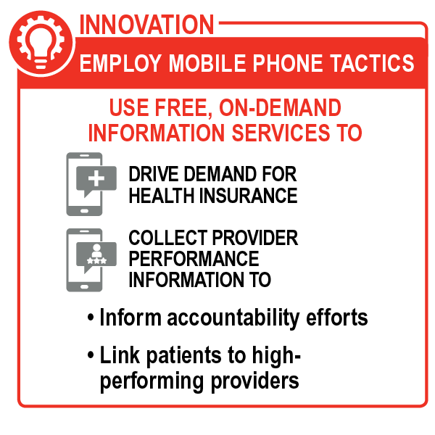 ***Implement results-oriented QI projects.*** In Years 3–5, IHI will collaborate with MSP, SNS, and private facilities to design and implement results-oriented QI initiatives. These will incorporate lessons from CMP prototype projects to strengthen the quality of MNCH services offered by PHC facilities and UNICEF/MSP’s evaluations, and will be implemented in 75 health centers. Concurrently, IHI will build the capacity of MSP, SNS, and health facility staff to expand QI projects throughout the DR. Abt will support SENASA to: 1) redesign payments to hospitals for deliveries and other services based on achievement of PAHO/WHO quality criteria, and 2) strengthen hospital reporting for receiving these payments. In addition, we will use umbrella-arrangement GUCs (see Exhibit 2**)** to help local IPs explore capacity development techniques that will strengthen QI and improve service delivery models among smaller NGOs.
* ***Build increased demand for quality***. We will exploit the DR’s ubiquitous mobile phones by using free information services (see box), as SHOPS Plus has done in Haiti. With Internews supporting a media information campaign to the public and a UNDP-led advocacy effort in Year 3 we will introduce—through the MSP—a feedback mechanism on provider performance. Banyan will collaborate with UNICEF and INSALUD to guide gender assessments to inform the tailoring of messaging and message channels to reach women, ensuring that women are engaged and have a voice in strengthening accountability for access to quality MNCH services.

Exhibit 16: Selected Ways DR Activity 2 Addresses all Three Health Systems Dimensions

| **Obj 1:** **Financial Protection** | **Obj 2: Population Coverage** | **Obj 3: Service Coverage** |
| --- | --- | --- |
| Prompt and predictable cash flow to hospitals could serve to reduce patients’ OOP expenses related to stock-outs of supplies and drugs at hospitals. | Patients in rural areas and poor and marginalized populations will have increased access to quality MNCH services as a result of QI and QA mechanisms. They will have primary care that is more responsive to their needs as a result of innovations using mobile phones to increase accountability. | Clinical effectiveness and user satisfaction will increase as the quality of MNCH services improves due to increased compliance with clinical guidelines and protocols. |
| ***Gender and social inclusion impact.*** Women will receive more compassionate, better-quality care. The maternal mortality ratio and infant mortality rate will fall due to greater access to and higher quality of maternal and reproductive health services. | | |

#### Capacity Building for Transition

The Abt Team will work through high-capacity IPs and provide coaching, training, and quality assurance to expand the number of trusted Dominican NGOs, universities, and firms that can support the health system. In this way, we will build their capacity to take on increasing responsibilities within the health system. We have already identified potential partners in the DR, including the NGOs in Exhibit 17 (laid out as described in the Ghana technical approach).

Exhibit 17: Transition to Local Partners in the Dominican Republic

|  |  |  |  |
| --- | --- | --- | --- |
| **Illustrative Local Partners** | **Illustrative Local Partner Roles in HSS and under Task Order** | **Task Order Role**  **Years 1–3: Capacity Building** | **Partner Status**  **Years 3–5: Transition** |
| *Instituto Dominicano de Dermatología y Cirugía de la Piel Dr. Huberto Bogaert* | Build capacity of smaller NGOs and firms in grants management, administration, and organizational development (Activities 1 and 2) | Support training, tools and processes to strengthen consulting business management (through umbrella GUCs and TA) | Receive GUCs and USAID transition awards; Prepare for direct contracts from GODR, and fees from NGOs for TA |
| *Insalud* and its 57 member non-profit associations implementing USAID’s Local Capacity Initiative | Provide technical capacity building for smaller NGOs (Activity 2) | Build capacity to provide TA (through QA and umbrella GUCs); Strengthen management of USAID grants; Strengthen financial and organizational development (through TA) | Receive GUCs and USAID transition awards for TA; Prepare for contracts from GODR; Prepare for collection of fees from NGOs for TA |
| *GIS Grupo Consultor* | Deliver TA for supply chain, social insurance; Support national policy formulation (Activity 1) | Build capacity to provide TA (through GUCs); Build capacity for management of USAID grants and contracts (through TA and QA from R4D and subcontract) | Receive subcontracts for TA, followed by USAID transition award; Receive GODR contracts |
| *Fundación Plenitud* | Deliver TA for health financing and economics; Support national policy formulation; Provide capacity building (Activities 1 and 2) | Support expansion into new technical areas; Build systems for business growth (through TA and QA from Abt) | Receive direct government TA contracts |

#### Learning and Adaptation

The Abt Team will use rapid feedback mechanisms to continuously improve activities and test alternative approaches to addressing complex problems. We will apply these methods in particular to efforts to increase informal worker enrollment in SNS and address evasion in the contributive scheme. The MSP, SNS, private sector, and NGOs will use ongoing learning from rapid feedback results to scale up QI projects to 75 facilities.

# Key Personnel and Staffing

The Abt Team brings the right balance of technical and functional skills and global and country-level experience to meet all Task Order objectives.

## Key Personnel

Our key personnel have already worked together on HFG, and bring complementary areas of technical expertise—our Project Director is a thought leader in health governance, policy, and financing; our Technical Director has internationally respected expertise in financial protection and population coverage; and our MEL Specialist combines experience with global frameworks and knowledge of on-the-ground implementation (see Exhibit 18). This technical know-how is coupled with soft skills such as diplomacy, a cooperative spirit, and a fierce commitment to fostering a culture of innovation and achieving powerful public health impact.

Exhibit 18: Key Personnel—Exceeding Task Order Requirements

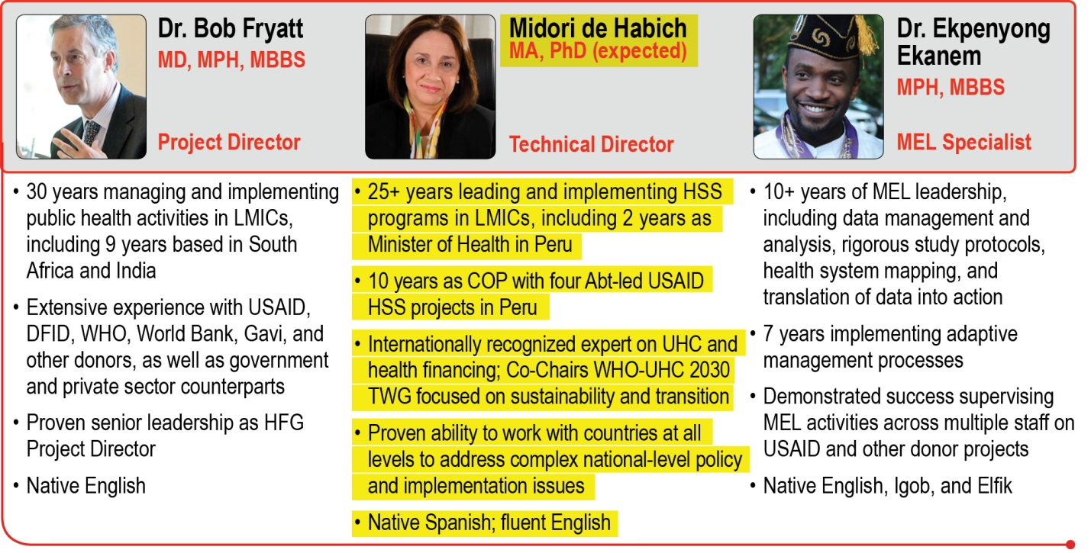

### Project Director Dr. Bob Fryatt

Renowned global public health expert **Dr. Bob Fryatt** will serve as Project Director. As a medical doctor, global HSS and service delivery reform specialist, published author, and thought leader in health financing and health policy, he has the expertise to partner with USAID, donors, and country teams to achieve Task Order objectives. Dr. Fryatt was Project Director for HFG, where he guided field implementation in more than 40 countries and oversaw 80 home office staff and more than 120 country staff. As the UK DFID resident Senior Health Advisor in South Africa, Dr. Fryatt helped bring credibility to the National Department of Health by facilitating a suite of reforms that have now expanded to the entire nation. The reforms included financial management improvement, establishment of an office for health standards compliance, and roll-out of results-based PHC. He also guided DFID’s support for a regional gender-based violence prevention initiative. In addition, Dr. Fryatt set up the WHO/World Bank International Health Partnership, which led to major efficiencies and boosted the impact of external HSS assistance in LMICs. The Partnership now covers more than 50 countries and aims for UHC by 2030. Dr. Fryatt will set the project’s strategic direction, establish consensus on vision and priorities, and provide overall leadership. He will foster effective teamwork; maintain strong relationships with USAID and partners; and cultivate smooth relations among Abt Team partners. Dr. Fryatt will be the primary contact for all Task Order-related issues, with overall responsibility for quality assurance of deliverables and engaging with the Health Systems GPG BAA mechanism.



Setting the Standard as Project Director

“Dr. Fryatt[’s]… thorough understanding and insight into global health systems enables him to develop solutions for different levels of the health system. He is one of very few public health experts worldwide who are able to catalyze and facilitate important change in challenging circumstances.”

–Jeanette Hunter, Deputy Director-General, Primary Healthcare, Republic of South Africa Department of Health

### Technical Director Midori de Habich

Technical Director ***Ms.*** ***Midori de Habich*** will provide technical management and quality assurance for the Task Order. She is a global HSS leader and expert in financial protection and population coverage. She participates on WHO UHC technical working groups, including as Co-Chair of the WHO-UHC 2030 sustainability, transition from external aid, and HSS and Health Financing TWGs, and is a sought-after speaker in global fora on HSS issues. She led HFG workshops on strengthening MOH/MOF relationships. She has also advised several governments on UHC and health financing including Ghana, Kenya and Cote d’Ivoire. As Minister of Health for Peru, she spearheaded comprehensive reform efforts that extended public health insurance to 15 million citizens. She is an experienced manager of USAID programs, and served for 10 years as Chief of Party (COP) for the Abt-led, USAID-funded Partners for Health Reform plus (PHRplus), Promoting Alliances and Strategies (PRAES), Health Systems 20/20, and the Health Policy Reform projects in Peru. Ms. de Habich will guide country teams to think creatively about new solutions and approaches that align with and contribute to global good practice. She will help define mechanisms for QI at the outset, during co-design, and as deliverables are completed. She will also ensure that emerging knowledge and innovative solutions are adapted and integrated into Task Order programs, and promote the use of existing formal and informal networks to facilitate peer learning and exchange. Ms. de Habich will oversee the global technical expert pool, and be responsible for quality assurance of technical approaches and major project deliverables.



Bringing global HSS and financing knowledge

“Having former Minister de Habich at this workshop was exceptionally valuable. Her real experience with how to negotiate between health and finance and the principles and lessons she had for us show us how we can do it.”

–Dr. Koku Awoonor, Director, Ghana Health Service

### MEL Specialist Dr. Ekpenyong Ekanem

As MEL Specialist, ***Dr. Ekpenyong Ekanem*** will apply his expertise to lead the development and implementation of MEL planning and activities for the Task Order. He is known for collaborating with USAID’s Office of Health Systems to build the Health Systems Benchmarking Tool, a multi-sectoral indicator database that supports the quantification and analysis of the performance of countries, regions, or established policy targets. As the HFG/Nigeria M&E Lead for the last three years, Dr. Ekanem supervised and coordinated MEL activities and learning across 14 staff in 11 states. He has collaborated with USAID, DFID, and BMGF, and with local teams in multiple countries to mobilize a variety of MEL approaches, resources, and tools, helping transition them into local hands—simultaneously building capacity and strengthening health systems. Dr. Ekanem will set the standards for field teams to develop agile, country-specific MEL plans consistent with USAID global best practices and tailored to individual contexts. He will oversee the monitoring of progress toward Task Order goals, feeding into the Health Systems GPG mechanism. Dr. Ekanem will ensure that quality data is collected across partner countries, analyzed, and used to inform planning and budgeting processes within the Task Order, as well as to inform advocacy efforts for use with partner governments and other HSS stakeholders.



Fostering Learning and Adaptation

“Ekpenyong is doing such a great job working with our partners… He is … doing it in such a positive way with the team. We really appreciate Ekpenyong's can-do attitude.”

– Christie Billingsley, Malaria Advisor, USAID-PMI/Zimbabwe

## Staffing Plan for All Staff

The Abt Team’s staffing plan is based on technical and programmatic need and a cost-effective mix of skills and labor among the prime contractor, subcontractors, local staff and partners, and home office personnel, all with longer-term transition in mind.

### Staffing and Management Structure

Drawing on a structure that has proven successful under global USAID projects held by Abt, we will decentralize management and decision-making authority to the country level to the maximum extent possible. Our team’s ***organizational structure*** (see Exhibit 29 in Annex 2) provides a cost-effective, flexible, responsive, and efficient platform for in-country collaboration. Direct links between our team’s international experts and our in-country specialists and IPs will foster learning and information-sharing.

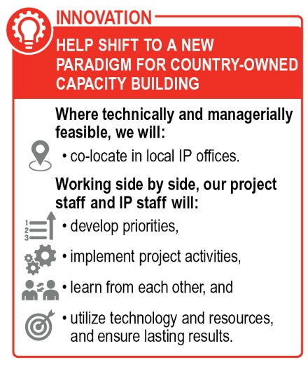***Country program management.*** To promote sustainability and efficient use of resources, our ***country teams*** will work with or through local leadership and IPs from the start, building their capacity for self-reliance after the Task Order ends. We will capitalize on the Abt Team’s extensive on-the-ground operations and networks to ensure we understand the context, mobilize the best country staff and experts, facilitate rapid start-up, and make the best use of resources. For example, we will build on an innovative approach Abt is using under the USAID/Uganda Integrated Community Agriculture and Nutrition Activity (see box). Abt’s regional Activity teams are co-located in the offices of local IPs, thus building local IP capacity, reinforcing sustainability, and reducing costs. Our ***Chiefs of Party*** will lead in-country work, reporting to our team’s Regional Managers. They will liaise with governments, USAID, and local leaders and partners; mobilize expertise; ensure project performance; and create an environment for learning and adaptive management (see Exhibit 27 in Annex 1 for illustrative examples of Abt Team COPs). In countries receiving STTA only, we may identify a local IP to coordinate activities, as proposed in the DR, to ensure an integrated approach. In each country, we will form a ***Transition Advisory Group*** (TAG) to enable continuous monitoring of transition progress (see box).

**Who?** Representatives of IPs in each Task Order country.

**Why?** Provide feedback on appropriateness and adequacy of transition strategies and mechanisms across task order. Contribute to annual report on sustainability and transition (see section 1.1.6).

**How?** Virtual meetings through Webex, co-chaired by Dr. Fryatt and IP representatives.

*The TAG: An unyielding focus on transition*

A ***Senior Management Team*** (SMT) will guide technical, operational, financial, and managerial compliance of the overall Task Order. The SMT is composed of senior Task Order technical and management staff. All core partners will be represented (see Exhibit 29). The SMT will respond rapidly to requests for work and provide in-country and virtual support to country programs.

***Overall Task Order support.*** As shown in Exhibit 29 in Annex 2, ***Project Director Bob Fryatt*** will lead interaction with the Contracting Officer Representative and Abt Team partners. He will moderate both the TAG and the SMT. Dr. Fryatt will supervise the Technical Director and MEL Specialist, as well as: 1) the ***Transition and Sustainability Director***, who will guide the scale up of in-country capacity building strategies, including plans for transitioning to locally supplied TA, and monitor progress on the SaTI; 2) the ***Senior Finance and*** ***Operations Director***, who will ensure operational consistency and compliance across the Task Order and oversee financial management, procurement, asset management, contracts, and HRH; the 3) ***Capacity Building Director****,* who will oversee adaptation and use of the OCB framework (see Exhibit 23 in Annex 1) and related monitoring; and 4) ***Regional Managers***, who will phase in as the Task Order adds countries to support rapid start-up; mobilize and participate in surge support and STTA; and ensure cross-country oversight, orientation, and skills-building.

***Rapid start-up.*** All of our senior staff are current Abt or partner employees, so we can start work on the Task Order immediately upon award. The Abt Team has a long track record of scaling up multiple country programs simultaneously and at speed. Abt and our partners currently have active offices and staff in all 54 priority countries, giving us the in-country logistical resources to support rapid initiation of activities. Using the proven protocols in Abt’s International Site Start-Up Procedures Manual, we will field project teams in an average of 30 days.

***Careful stewardship of resources.*** Under HFG, we learned the importance of a clear and plan for cost containment for in-country programs. Based on this lesson, we have embedded cost efficiency principles in our approach to task order management: 1) maximize use of local staff and expertise; 2) use competitive bidding to source in-country partners/vendors; 3) co-locate in existing offices; 4) collaborate with other initiatives; and 5) use cost-efficient IT and MEL tools.

### Staff Qualifications

***Senior Management Team.*** Our SMT team draws from HFG and includes specialists from other HSS projects to bring fresh ideas. In addition to our key personnel, SMT members include:

* ***Lisa Tarantino,*** Transition and Sustainability Director/Regional Manager for Europe and Eurasia, Latin American, and the Caribbean (Abt), developed a sustainability framework being used by four Caribbean countries to transition HIV responses away from donor support. In the Philippines, Ethiopia, Eastern Europe and elsewhere she managed programs to strengthen health services’ sustainability with HSS and PPP programs.
* ***Margaret Morehouse,*** Senior Capacity Building Specialist (TRG), has led institutional strengthening efforts in the public sector (e.g., establishment of an HIS Directorate in the MOH in Namibia) and in the non-governmental sector (e.g., organizational strengthening of the regional African Field Epidemiology Network).
* ***Eric Sarriot,*** Senior Advisor for HSS/Regional Manager for East and Southern Africa (SC), previously led the community health and civil society engagement team under USAID's Maternal and Child Survival Program. He is a member of the WHO Network to Improve Quality of Care for MNCH and helps set WHO guidelines for CHW programs.
* ***Sodzi Sodzi-Tettey,*** Senior QI Specialist (IHI), is currently the Accra-based Head of the Africa Region for IHI. He led the Fives Alive! Project in Ghana, which recorded a 34% reduction in under-5 deaths in 2015 and sustained a 25% reduction in newborn mortality.

Our SMT also includes Regional Manager for West Africa (Anglophone) ***Elaine Baruwa*,** Regional Manager for Asia, West Africa (Francophone), and Haiti ***Lisa Nichols***, Global Lead for Health Governance ***Peter Vaz,*** and Senior Finance and Operations Director ***Francisco Gonzales.***

***Roster of technical experts.*** The Abt Team fields a deep bench of world-class experts in all aspects of HSS, illustrated by the examples below and in Exhibit 28 in Annex 1.

* ***Karishmah Bhuwanee***, a senior health financing expert at Abt, is a thought leader who supports the WHO on the framework for resource tracking. She helped institutionalize resource tracking in 10 countries in Africa, Asia, and the Caribbean, including building technical capacity to produce health accounts and use data for better decision-making.
* ***Thomas Bossert*** is a widely published global health systems research thought leader who pioneered the innovative “decision space” approach for analyzing functions in decentralized health authorities. Dr. Bossert is currently the Director of the International Health Systems Program at the Harvard T.H. Chan School of Public Health.
* ***Abdo Yazbeck*** is a senior economics advisor at Abt who has directed World Bank flagship courses on health finance. The author of several books on health and development, he is on the editorial committee of Harvard’s Journal of Health Systems & Reform.
* ***Amanda Folsom*** of R4D leads the HSS Accelerator’s country engagement and its first activity focused on strengthening community health outcomes in West Africa. She has overseen the design, scale-up, and management of the JLN and the Nigeria Subnational JLN.
* ***Thokozani Bvumbwe***, a member of THEnet’s Evidence Group, is a Senior Lecturer in Health Sciences at Mzuzu University in Malawi. He has developed and implemented community-based learning models in nursing education at Mzuzu University and elsewhere and is currently developing a new maternal and reproductive health training and research center.
* ***Victoria Rames***, senior gender technical expert at Banyan Global, has extensive experience conducting gender analyses for USAID programs and managing and evaluating large USAID and UN gender projects. As COP of the ADVANTAGE IDIQ Gender Integration TA task order, she leads on-demand support to USAID/GenDev and missions.
* ***Rachel Sanders*** is a technical expert for modeling at Avenir who co-developed and maintains the OneHealth Tool for strategic planning and costing of sector plans to scale up effective health interventions. She is experienced at training LMIC counterparts to develop and use costing and modeling data for advocacy, policy development, and program M&E.
* ***Julia Watson*** is a senior health financing specialist at Abt who previously led DFID’s global approach to HSS in LMICs. She is a founding member of the HANSHEP (Harnessing non-state actors for better health for the poor) knowledge exchange platform, where she guided policy development on strengthening mixed (private and public) health systems.
* ***Pamela Riley***, a Senior Digital Health Advisor at Abt, serves on the Advisory Board of the Global Digital Health Network and has used innovative digital survey methods for rigorous randomized controlled trials to evaluate health impact.

## Roles and Responsibilities of Prime Contractor, Subcontractors, and Resource Organizations

Under the leadership of Abt Associates as prime contractor, our four core partners, eight specialized partners, and local IPs will deliver the right expertise for every aspect of USAID’s vision for HSS (see Exhibit 19). All partners have clearly delineated roles to ensure that each one’s organizational experience, resources, and technical capabilities will be fully mobilized and that all contributions complement one another. Most importantly, our team members are experts in understanding and applying proven, practical, evidence-based, cost-effective, and scalable solutions appropriate for different countries at different stages of development.

We have retained HFG partners R4D, TRG, and Avenir; their expertise will play a key role in the Task Order’s capacity to achieve results. We have brought on IHI and the small business Initiatives, whose experience under ASSIST and elsewhere will support the Task Order to improve the quality and outcomes of health care services. SC will contribute a platform for working in fragile environments and bring extensive expertise strengthening community health systems and social accountability. Our team includes some firms with a long history working with USAID on HSS and some that are new to USAID. This powerful new partnership is committed to operating as a unified team and placing a premium on working through and empowering IPs in partner countries.

Exhibit 19: Abt Team Partner Roles, Responsibilities, and Lines of Authority

|  |  |
| --- | --- |
| **Prime** | **Roles and Responsibilities for Achieving Objectives** |
| Abt Associates | As prime contractor, lead ***TO management*** and quality assurance, compliance, client relationships, ***technical and financial oversight***, partner accountability and ***results achievement*** across all objectives. Specific roles have been agreed with partners: for example in Objective 1, Abt’s areas of responsibility include ***resource tracking***, in Objective 2, they include ***HRH*** policy and strategy, and in Objective 3, Abt’s areas of responsibility include ***clinical guidelines and private providers***. |
| **Core** | **Roles and Responsibilities for Achieving Objectives** |
| IHI | Under Objective 3, lead on ***improving quality of essential services***. Support governments to co-design health care ***quality strategies*** and establish ***QI capability*** across health system. Ensure strong governance mechanisms to sustain health care improvements so that facilities attain in-country regulatory standards. |
| R4D | Under Objective 1, lead on ***benefit packages*** and ***strategic purchasing***. Improve ***PHC performance***; strengthen accountability; and undertake ***equity and political economy analyses***. Advise on ***transitions*** and integration of Gavi and Global Fund. Leads USAID’s HSSA. |
| SC | Under Objective 2, lead work to strengthen ***community health systems*** and ***CHW roles*** in scaling up quality MNCH and nutrition services. Implement demand-side interventions to increase use of services, remove financial barriers, and increase ***social accountability***. Provide ***on-the-ground platforms*** for work in fragile environments. |
| TRG | Across all objectives, increase partners’ ***organizational capacity*** through direct engagement and by building project and IP capacity to undertake organizational capacity building work. |
| **Specialized** | **Roles and Responsibilities for Achieving Objectives** |
| Avenir | Support Objectives 1 and 2 through ***epidemiological and costing*** ***modeling*** for advocacy, impact, and coverage estimates. Build capacity to use modeling software such as the OneHealth Tool. |
| Banyan | Provide guidance on ***private sector*** health financing. Lead on ***gender, female empowerment, and social inclusion*** strategies, guiding work of Abt and SC in-country teams and IPs across all objectives. |
| Harvard | Deliver support to build ***health systems research*** capacity. Contribute state-of-the-art expertise in systems thinking, decentralization, governance, quality, resilience, and sustainability. |
| HISP | Work through local partners to assist in adapting and rolling out ***DHIS2.*** Build local partner understanding of the software, surveillance, and using ***data for decision-making*** across all objectives. |
| Initiatives | Support ***QI workforce requirements*** and related HR performance appraisal systems under Objective 3. |
| Internews | Assist governments, civil society, and others in using ***media*** ***for health advocacy*** and ***to promote UHC***. Develop communication strategies across all objectives. |
| McKinsey | Support work on ***fiscal space, impact bonds, PFM, tax revenue.*** Advise on medical products and technologies. |
| THEnet | Use existing network to apply innovative approaches to strengthening ***health workforce*** in underserved areas, including through pre-service education, to expand coverage and improve quality and responsiveness of services. |
| **Local IPs** | **Roles and Responsibilities for Achieving Objectives** |
|  | Take leadership roles on implementation—details in Ghana, Uganda, and DR technical approaches. |

# Monitoring, Evaluation, and Learning Plan for Uganda

This draft MEL Plan (MELP) for Uganda describes how we will collaborate, learn, and adapt our programming to deliver results. We will monitor Task Order performance and draw on principles of complexity-aware monitoring where necessary to capture our contributions within the context of the wider changing health system. Our MEL activities will strengthen existing information systems so we can continuously incorporate local contributions into our learning, thus building local capacity directly and indirectly. We will collaborate with MEL stakeholder groups in the MOH and its partners to select a set of common indicators and measurement approaches that will align our learning agenda with the needs of the country and with USAID/Uganda’s CDCS.

## Theory of Change

Exhibit 20: Theory of Change

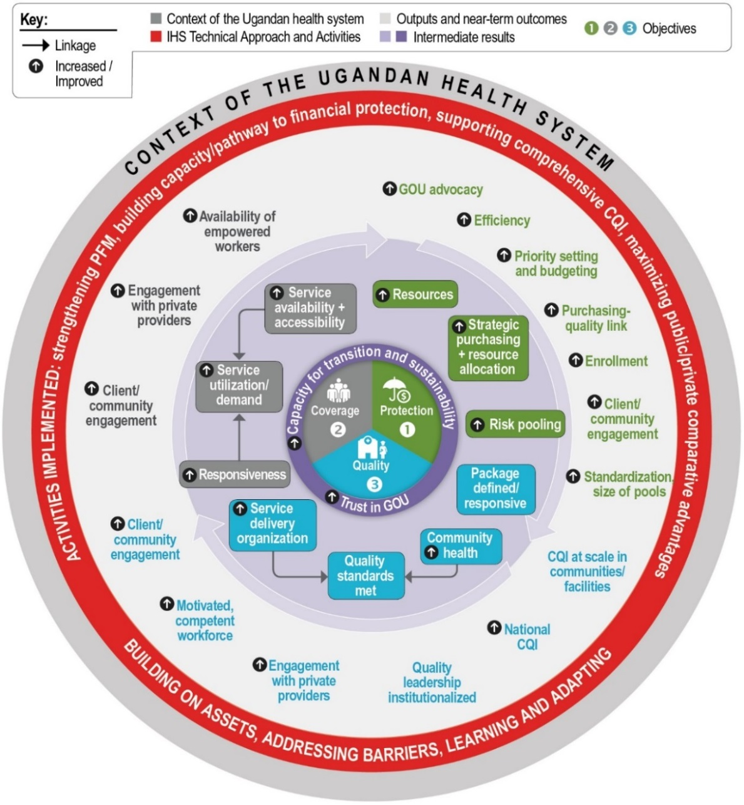

The Abt Team’s Theory of Change (ToC) is summarized in Exhibit 20. This shows at a high level the progression from the current state (the outermost ring) to the desired end state (the center), and the causal linkages between our evidence-based activities and their contribution towards achievement of outputs, near-term outcomes, and intermediate results. Causal pathways are not linear, and single interventions will influence multiple near-term outcomes and intermediate results at once, directly and indirectly. The arrows showing movement around the circle depict our expectation of system-wide effects—activities and outputs contribute to more than one objective. We have leveraged this in our activity design to influence change through multiple pathways simultaneously. Upon award, we will use this draft as a starting point to develop a robust and jointly agreed upon ToC with a broad range of Ugandan stakeholders. The final ToC will include validated causal pathways and a complete list of assumptions with strategies for mitigating risk. The ToC will remain a living, evolving document that will help us respond effectively to the changing context. Our MELP will include approaches to regularly test the causal pathways and assumptions underlying our ToC as part of our overall plan to support learning and adaptation to ensure interventions contribute to the project objectives and goal.

## Results Framework

The Abt Team’s Results Framework (Exhibit 25 in Annex 1) demonstrates how the program will contribute to USAID/Uganda’s CDCS and respective Development Objectives (DO), with a substantial link to DO3 and respective IRs and sub-IRs, as well as DO1 and DO2. The framework depicts a causal pathway from Task Order activity inputs and outputs to objectives and IRs to its desired outcomes and ultimate impact. We have customized the IRs and selected sub-IRs provided by USAID to the Uganda context and our technical approach, and added new sub-IRs to the framework to better elucidate the factors we intend to influence directly and indirectly through our interventions. To capture an important element of our overall systems approach, we also added three customized cross-cutting IRs that will be addressed through multiple interventions simultaneously, and which also serve as an important pathway (and condition) towards achieving the overall goals of transition and sustainability. These cross-cutting IRs focus on: community and client engagement and voice; capacity building of Ugandan institutions; and collaboration across public, private, and civil society actors. The framework also highlights the inputs, processes, and activities that will contribute to the intended results. It does not *visually* depict all of the likely direct, indirect, and systems effects that may occur but only the most relevant results. This is because activities are intentionally designed to influence multiple results holistically and simultaneously. In alignment with our co-assess, co-create, and co-implement approach to working with local IPs, we will develop comprehensive ToCs and Results Frameworks in each country to validate contextual and programmatic assumptions; we will test/adapt our ToCs, and ensure all activities effectively contribute to our intended results.

## Methods to Monitor Performance and System-Wide Effects and Changes

As we work toward the results depicted in the Results Framework, we will monitor performance by tracking a mix of project-specific ***process, output,*** and ***outcome indicators*** that will facilitate continuous learning and adaptive management and improve accountability and program effectiveness. A comprehensive illustrative summary can be found in the draft Performance Indicator Tracking Table (PITT) in Exhibit 26 in Annex 1. Our regular program review activities and meetings, particularly every six months when we ***pause and reflect***, will start with a review of these indicators, their targets, and progress toward the targets.

In addition, proactive tracking and interpretation of influencing factors using ***context indicators*** will help us monitor and understand the Task Order’s contributions to ***system-wide effects****.* Context indicators will examine socioeconomic and demographic changes (such as per capita GDP or the percentage of people living in extreme poverty) and changes in political commitment (such as domestic budget allocations for priority diseases) to help us understand how to best adapt our interventions. Context monitoring will form part of our ***complexity-aware methods,*** which capture direct and indirect cause-effect relationships and the system-wide effects of project interventions in a complex environment. This will include ***process monitoring*** to, for example, understand *how* and *why* our interventions to pool CBHI and voucher schemes contribute to the effective implementation of an essential benefits package (see Section 3.5).

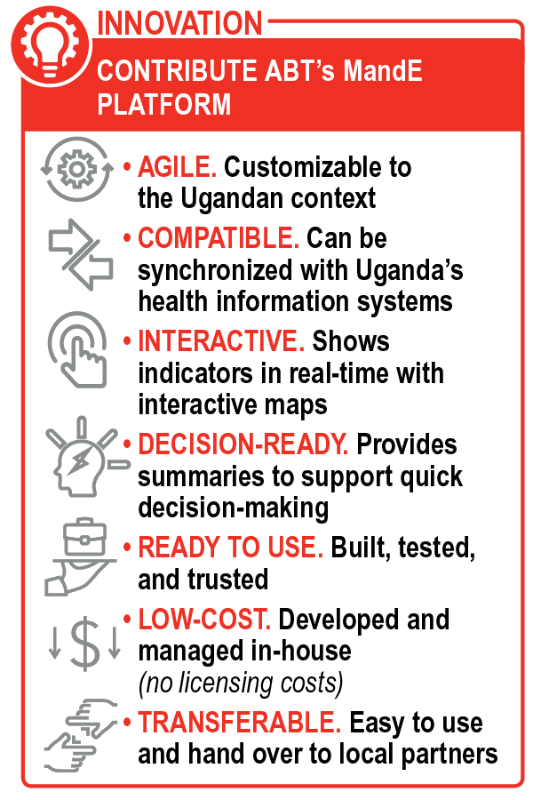To track indicators and key deliverables, we will customize Abt’s in-house integrated web-based MandE platform (see box) to facilitate data submission, collation, and analysis of Uganda-specific interventions across health system functions. The HFG project successfully used MandE to track deliverables in 34 countries, four regions, and centrally; it allowed simultaneous cross-country reporting of activities and results by multiple partners. We will further tailor MandE for country-specific needs and to train IPs to use the platform independent of Abt support.

### Approach to Utilizing and Strengthening Uganda’s Existing Routine Information Systems and Data

As we monitor performance and system-wide effects and changes, the Abt Team will use ***existing information systems*** and GOU sources for project monitoring. These include the MOH’s Health Management Information System (HMIS/DHIS2), Logistics Management Information System (LMIS/DHIS2), and iHRIS, as well as the MOF’s Integrated Financial Management System. HISP will assist with integration into DHIS2. Certain outcome indicators (e.g., percentage of population covered by insurance) will also rely on ***data from existing national surveys***, including the Demographic and Health Survey, National Household Survey, and National Governance Baseline Survey, as well as on surveys planned by other projects or donors. For example, as shown in the PITT, we will use data from the HMIS (and other sources) to place Uganda on the UHC tier index for financial protection, service capacity, and equity/population coverage. We will simultaneously build the availability and quality of data within corresponding country systems (e.g., strengthening MOH’s capacity for program-based expenditure tracking) by using data dictionaries and other standardization processes.

### Data Quality Assessment Plans and Procedures

MEL Specialist Dr. Ekanem will work with Ugandan MEL specialists to coordinate in-country data quality assurance (DQA) mechanisms. We will use DQA principles to enhance the quality of the initial data generated through local sources, while also building DQA capacity among local partners. We will use third party-administered standardized DQA tools such as checklists, data verification worksheets, and performance indicator reference sheets to assess *internal* data generated by the project and *external* data gathered through Uganda’s existing public and private sector information systems and sources (see Section 3.3.1). Our team will incorporate DQA assessments into our routine progress reviews. Data quality will be improved by agreeing on data standards, refining collection tools, and boosting the capacity of data collectors. These DQA mechanisms will help ensure high-quality, reliable monitoring data that meets USAID data quality standards while also establishing sustainable DQA after the Task Order is completed.

### Methods to Measure and Monitor Local Partner Capacity

The Abt Team will embed the measurement of local capacity into our technical approach by working with IPs to define capacity constraints and co-create solutions. Section 1.1.2 and Exhibit 23 in Annex 1 include details on our ***OCB approach***, which includes the establishment of benchmarks for measuring progress toward sustainability and transition readiness. We will use the OCB approach established under HFG for governments and larger institutions, and the rigorous, metrics-driven ***ProCapacity IndexTM Tool*** thatAbt developed under the SHOPS projects for NGOs and smaller service providers. The results of these assessments—together with indicators that assess progress across the three health system dimensions, as summarized in the PITT—will enable us to prepare an aggregated country-wide ***SaTI***. The SaTI will be an easy-to-read summary dashboard of progress on all Task Order work in Uganda (see example MandE dashboard in Exhibit 24 in Annex 1). We will prepare the SaTI through a participatory in-country approach, with results included in the Task Order’s annual report.

## Collaboration, Learning, Adapting, and Knowledge Management

In order to integrate CLA and KM into the Task Order, we will implement the following:

* ***Generate and synthesize knowledge* to c*reate a common understanding of the problems and proposed solutions*—**to jointly analyze existing evidence with stakeholders and inform program design decisions. We will ensure targeted information is synthesized in digestible and actionable formats, and where there are evidence gaps, conduct additional analyses.
* ***Identify evidence and knowledge gaps to craft a local learning agenda***—agendas will include priority questions related to program quality and key barriers. With local partners, we will design, implement, and analyze the results of research on, for example: strategies for strengthening PFM; pooling resources across CBHI schemes; andincentives and disincentives for students serving in under-served areas.
* ***Select and collaborate with local KM champions—***to build sustainable capacity in KM, local partners will serve as leads on knowledge sharing and application. These champions will have experience in facilitation to promote a KM culture.
* ***Implement rigorous monitoring for learning***—we will collect, analyze, and synthesize data on activity performance, progress towards results, lessons from pilots or new innovations, research or assessment findings, and strategic analysis and synthesis of secondary data.
* ***Conduct intentional ‘reflect and refocus’ workshops***—to review progress and identify where changes are required, focusing on country-specific evidence and learning. Local KM champions will participate. We may plan similar events at the regional or global level.
* ***Hold quarterly participatory reviews***—to monitor progress against the work plan; discuss implementation issues; continuously update staff on achievements; and share best practices.
* ***Facilitate milestone reviews and annual work planning***—these structured, formal exercises, will reflect on the ToC; jointly pause and reflect on approaches and need for adaptations; and analyze performance data to facilitate advance planning.
* ***Implement knowledge management and communication plans***—to identify targeted activities and tools for documenting and sharing good practices and results. Our KM and communications efforts will be strategically designed with each target audience in mind.

### Project Monitoring and Adaptive Management for Learning

Our MEL and KM teams will work collaboratively on learning efforts within countries and across the Task Order. Our full Uganda MELP will serve as a comprehensive performance management tool, and will include a comprehensive KM Plan that outlines how we will continuously generate data and apply it to learning. Our MELP will help detect the following: changes in context that affect project implementation and that require adjustments in approach; successful activities and strategies that should be documented, disseminated, and scaled up; and, activities and strategies that are not achieving intended milestones and results and need to be adjusted. This learning-focused MELP will provide a routine source of relevant information to internal and external decision-makers, and help promote a learning and adaptive management culture. We will use the approaches outlined in Exhibit 21 to ensure alignment of MEL and KM to guide the generation and use of data for learning and adapting.

Exhibit 21: Key Processes for Analyzing and Using Data for Learning and Adapting

|  |  |
| --- | --- |
| **Process** | **Purpose** |
| **Rapid cycle analytics** | Analyze results in major technical areas, identify lessons learned, and develop specific actions plans; generate modeling results to estimate likely effects of continued or refined efforts. |
| **Reflect and Refocus workshops** | Review the results of priority evaluations and research efforts, including baseline, mid-term, and end-of-project evaluations. Provide opportunities to reflect on approaches with IPs and senior manager and consider the need for adaptation of approach. |
| **Quarterly participatory reviews** | Monitor and track progress against the work plan; discuss implementation issues; continuously update staff on activities completed and achievements against targets; share best practices and real-time learning to facilitate agile adaptation. |
| **Milestone reviews and annual work planning** | Reflect on ToC based on experiences and lessons to date; jointly pause and reflect on approaches and need for any adaptations; provide performance data and contextual monitoring information to facilitate advance planning and assessments of expected and unexpected effects of all proposed annual work plan activities. |

## Single Evaluation Study Design

Throughout the Task Order, specific bottlenecks will require small, customized study designs to find solutions or to review options for progress. One example might be the need to refine our intervention approaches for improving financial risk protection for Ugandans, which would require deeper understanding of the implementation results of recent RBF and user-centric initiatives such as the Abt-managed Voucher Plus project, as well as the experience of CBHI programs. For such an evaluation study, we propose the illustrative design shown in Exhibit 22, which integrates complexity-aware methods to answer our key evaluation questions.

Exhibit 22: Illustrative Evaluation Study Design that Integrates Complexity-Aware Methods

|  |  |  |
| --- | --- | --- |
| **Theme** | **Key Evaluation Questions** | **Research Methodology** |
| **Identify causal chain behind results of NHI pilots** | What are the causal factors associated with successful and unsuccessful results of Uganda’s strategic purchasing pilots (e.g., RBF pilots, reproductive health voucher schemes, USAID Voucher Plus project led by Abt)? | ***Mixed methods sequential explanatory study*** that incorporates desk reviews of the results of previous RBF pilots and user-centric initiatives with analysis of secondary data (e.g., scheme enrollment, claims data). This will be integrated with semi-structured key informant interviews with stakeholders to capture diversity of perspectives and need for scale-up. Findings will incorporate complexity-aware methods such as the *most significant change* approach and explore the direct and indirect factors affecting and leading to the recorded results, including the contextual effects of these interventions. |
| **Develop road map for achieving financial protection** | What is the best way to integrate existing initiatives, such as RBF pilots and CBHI schemes, into the NHI scheme while balancing increased demand with the need to avoid cost escalation and maintain quality standards? |

Annex 1: Illustrative Charts and Graphs

Exhibit 23: Abt Team Organizational Capacity Building Framework

|  |  |
| --- | --- |
| **Dimension** | **Definition** |
| **Organizational Development** | |
| Organizational mandate | Clearly defined official roles and responsibilities, accountability, and functions |
| Strategy and planning | Vision/long-term strategic direction with strategies and plans to implement/modify |
| Structure and staffing | Adequate organizational structure and staffing to carry out core functions |
| Implementation capacity | Capacity to plan, manage, improve, and monitor activities |
| Leadership and management | Leadership that sets direction, motivates and aligns staff behind strategic direction; management that works together, monitors staff performance, shares information |
| Gender and inclusion | Explicit gender and social inclusion practices and functions |
| Resources | Adequacy of basic operating resources in the short- and long-term |
| Coordination/stakeholder engagement | Capacity to engage and coordinate internal and external stakeholders |
| Organizational governance | Existence of a structure that provides oversight and ensures accountability |
| **Technical Capacity** | |
| Technical capacity | Technical skills and systems commensurate with functions (e.g., health financing, QI) |
| **Financial Management, Business Planning, and Compliance** | |
| Management systems, incl. financial | Well-defined and used systems for financial management, HR, IT, and procurement |
| Compliance | Systems/capacity to ensure compliance with government and USAID requirements |
| **Measuring Capacity** | |
| • Scoring system will be devised on a 1-5 scale for each framework dimension. Initial assessment will establish baseline.  • Yearly assessments will measure progress and provide information for learning making adaptations.  • Final end-line assessment will show overall progress.  • Assessment instrument will be designed as a participatory self-assessment mechanism  • Data collection tools will include a survey, possibly complemented by key informant interviews. | |

Exhibit 24: Monitoring Task Order Progress—Sample MandE Dashboard for Uganda

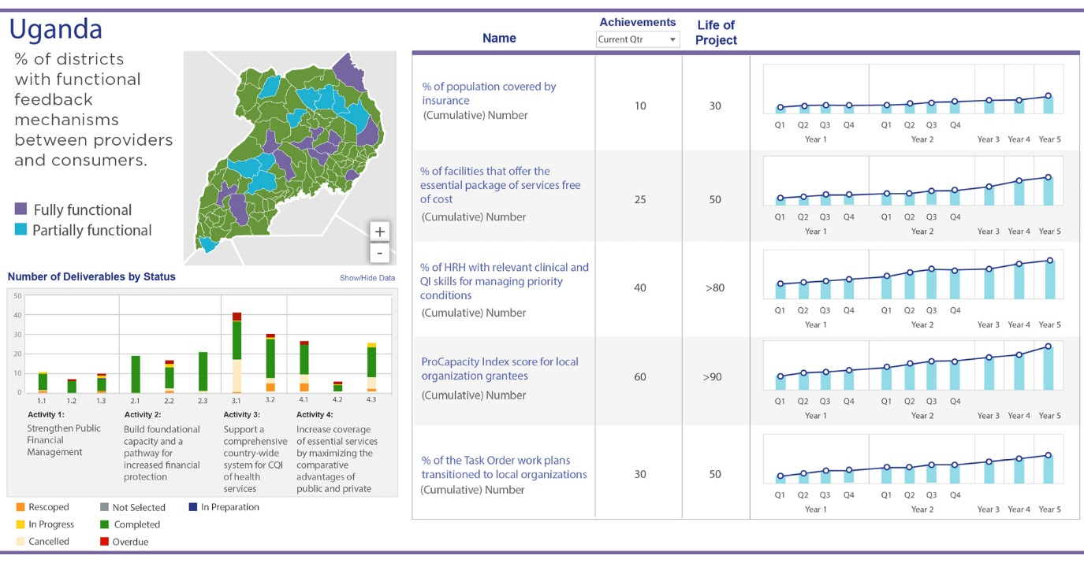

Exhibit 25: Results Framework for Task Order Uganda Program

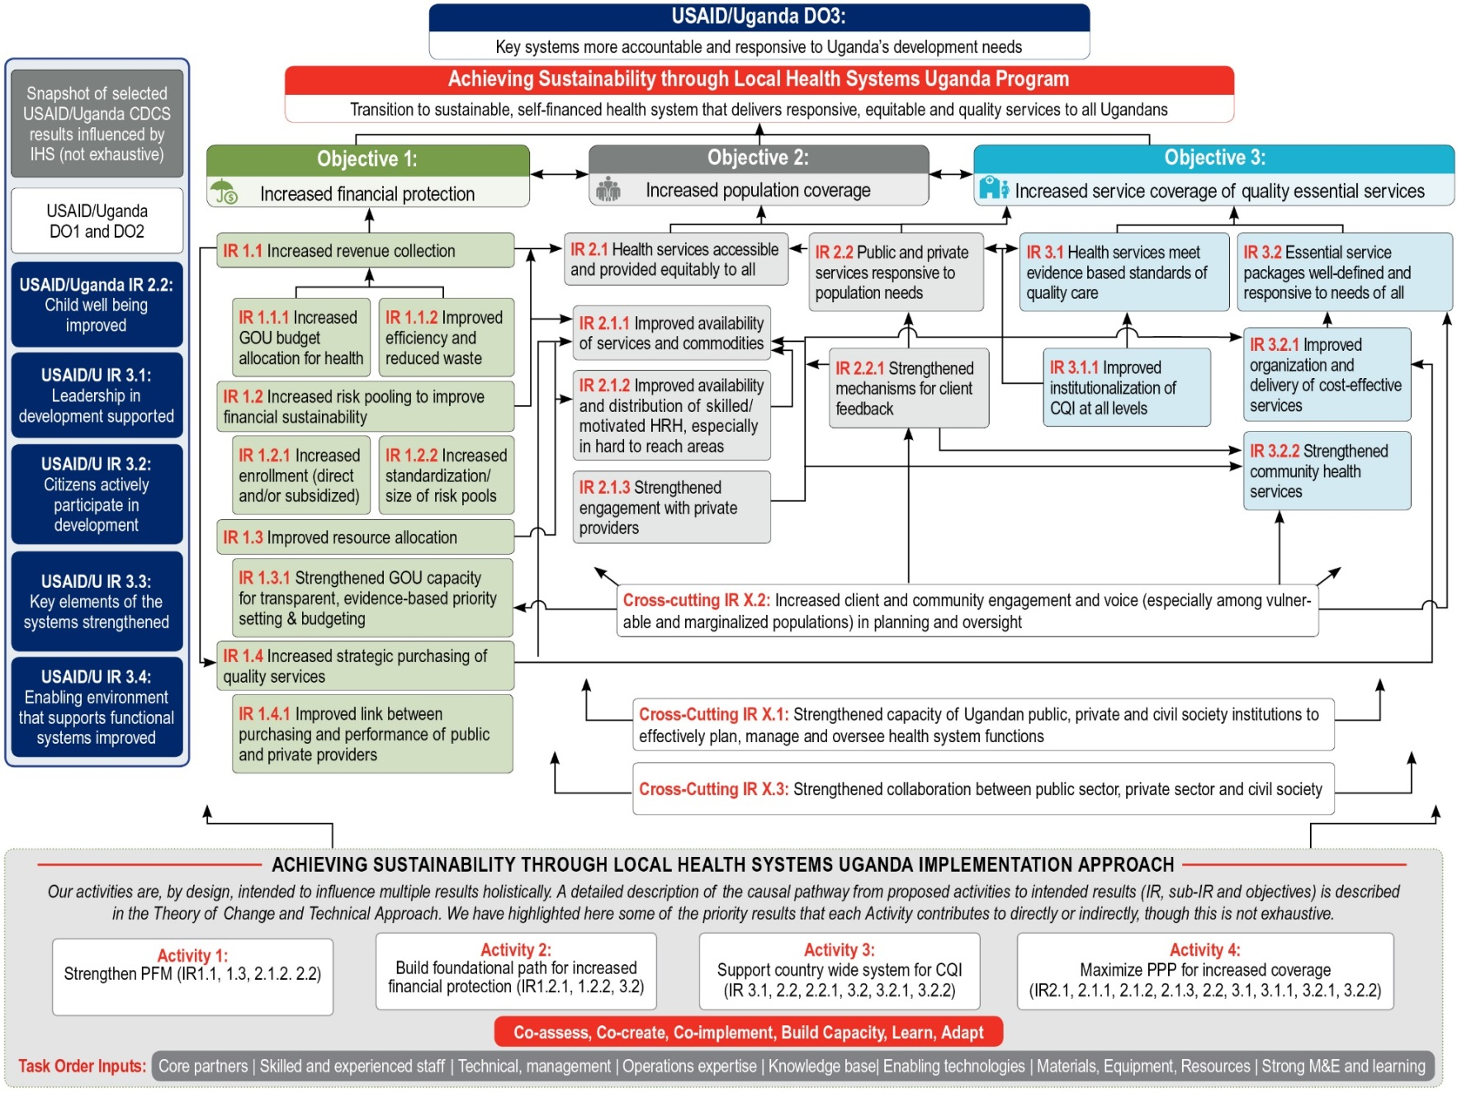

Exhibit 26: Task Order Uganda Program Performance Indicator Tracking Table (PITT)

| **Indicator1** | **Type2** | **Baseline (Year)** | **Targets** | | | | | **Data Source/**  **Collection Method** |
| --- | --- | --- | --- | --- | --- | --- | --- | --- |
| **Y1** | **Y2** | **Y3** | **Y4** | **Y5** |
| **Purpose: Universal health coverage achieved** | | | | | | | | |
| UHC tier index for financial protection, service capacity & equity/population coverage | [Oc] | TBD | +2% | +4% | +8% | +12% | +15% | WHO UHC Data Portal, MOH HMIS |
| **Result 1: Increased financial protection** | | | | | | | | |
| Health sector PFM capacity *(covering prioritization and execution of health budgets)* | [Op] | TBD | +5% | +15% | +25% | +40% | +60% | Task order (TO) capacity assessments |
| Incidence of catastrophic spending *(Sustainable Development Goal 3.8.2):* % with household expenditure on health > 10% of total expenditure or income○ (disaggregated by wealth quintiles◊) | [Ip] | 12% | 11% | 10% | 8% | 6% | 5% | WHO UHC Data Portal & TO analysis |
| % of health spending related to out-of-pocket spending | [Ip] | 41% | 40% | 37% | 34% | 31% | 28% | TO assessments / WHO Global Health Expenditure Database (GHED) |
| Domestic spending on health/Current Health Expenditure or Total Health Expenditure◊ *(disaggregated by public/private sources ◊ and essential services - HIV/TB and RMNCH)* | [Ip] | 7%  (2015/16) | 8% | 9% | 11% | 13% | 15% | WHO GHED/SHA, MOF, TO analysis |
| % of the population covered by insurance | [Oc] | 6% | 7% | 10% | 15% | 20% | 30% | Demographic & Health Survey / TO analysis |
| **Result 2: Increased population coverage** | | | | | | | | |
| UHC Service Coverage Index (SDG 3.8.1) ◊◊ | [Oc] | 44 | 46 | 50 | 55 | 65 | 75 | MOH HIS/ TO activity report |
| % of districts with functional feedback mechanisms between providers and consumers | [Oc] | 10% (2015) | 20% | 30% | 40% | 60% | 75% | TO activity report / MOH Health Sector Development Plan assessment |
| # of community-based organizations that formally participate in government decision-making at the national, state, and local levels ◊ | [Oc] | TBD | +5% | +20% | +40% | +60% | +80% | TO documentation based on country assessments / review |
| % of the poorest 40% of the population or disadvantaged populations who use essential health services (e.g., attended delivery, modern contraceptives, specialist visits) Δ | [Oc] | TBD | +5% | +15% | +25% | +40% | +60% | TO documentation based on country assessments / review |
| Client satisfaction with health services (as measured through quality of care indicators derived from USAID’s Service Provision Assessment (SPA)◊◊ *(adapted to include non-clinical aspects of care* ◊*)* | [Oc] | TBD | +5% | +10% | +20% | +35% | +50% | Analysis of existing SPA or other client exit surveys, TO survey / report |
| # trained with USG assistance to advance outcomes consistent with gender equality or female empowerment via their role in public or private institutions or organizations∞ | [Pc] | N/A | TBD | TBD | TBD | TBD | TBD | TO activity report based on country assessments / document review |
| **Result 3: Increased service coverage of quality essential services** | | | | | | | | |
| Healthcare quality and access index | [Oc] | 31 | 32 | 35 | 40 | 45 | 50 | GBD 2016 Health Access & Qual. Collab. |
| Mean level of compliance with applicable clinical guidelines for essential services (disaggregated by public and private sector providers) ◊ | [Oc] | TBD | +5% | +10% | +20% | +35% | +50% | MOH / TO activity report |
| % of HRH with relevant clinical and QI skills for managing priority conditions | [Op] | TBD | +5% | +20% | +40% | +60% | +80% | TO activity report / health facility survey |
| % of facilities that offer the essential package of services free of cost | [Oc] | TBD | TBD | TBD | TBD | TBD | TBD | MOH / TO activity report |
| % reduction in tracer medicine/vaccine stock out | [Op] | TBD | +5% | +20% | +40% | +60% | +80% | MOH HIS/statistics & TO analysis |
| **Cross-Cutting: Local Partner Sustainability and Transition** | | | | | | | | |
| GOU Capacity Development Framework score | [Oc] | TBD | TBD | TBD | TBD | TBD | TBD | TO institutional assessments* |
| ProCapacity Index score for local organization grantees | [Oc] | TBD | TBD | TBD | TBD | TBD | TBD | TO NGO assessments |
| % of the TO work plans transitioned to local organizations | [Oc] | 0% | 10% | 20% | 30% | 40% | 50% | TO activity report |

1 USAID Priority HSS Indicator, USAID HSS Vision 2015-2019; ◊◊ = USAID Principal Indicator for HSS Strategic Outcomes, USAID HSS Vision 2015-2019; ∞ = USG Foreign Standard Indicator (F indicator); ○ = SDG indicator or recommended standard WHO, World Bank, or UHC/Joint Learning Network indicator; Δ = Recommended indicator (if not included above) from USAID/Measure Evaluation HSS Compendium; Ԛ = Per State Department definition USG/F (HL-1, HL-1a-e) “foundation for measuring progress on achievement of UHC” * Organizational Capacity Development Measurement- https://www.usaid.gov/sites/default/files/documents/2496/Capacity_Development_Measurement_Recommendations_Final_Draft_5.11.2017_1.pdf

2 Process [Pc], Output [Op], Outcome [Oc], Impact [Ip] level indicators

Exhibit 27: Illustrative Examples of Abt Team Chiefs of Party

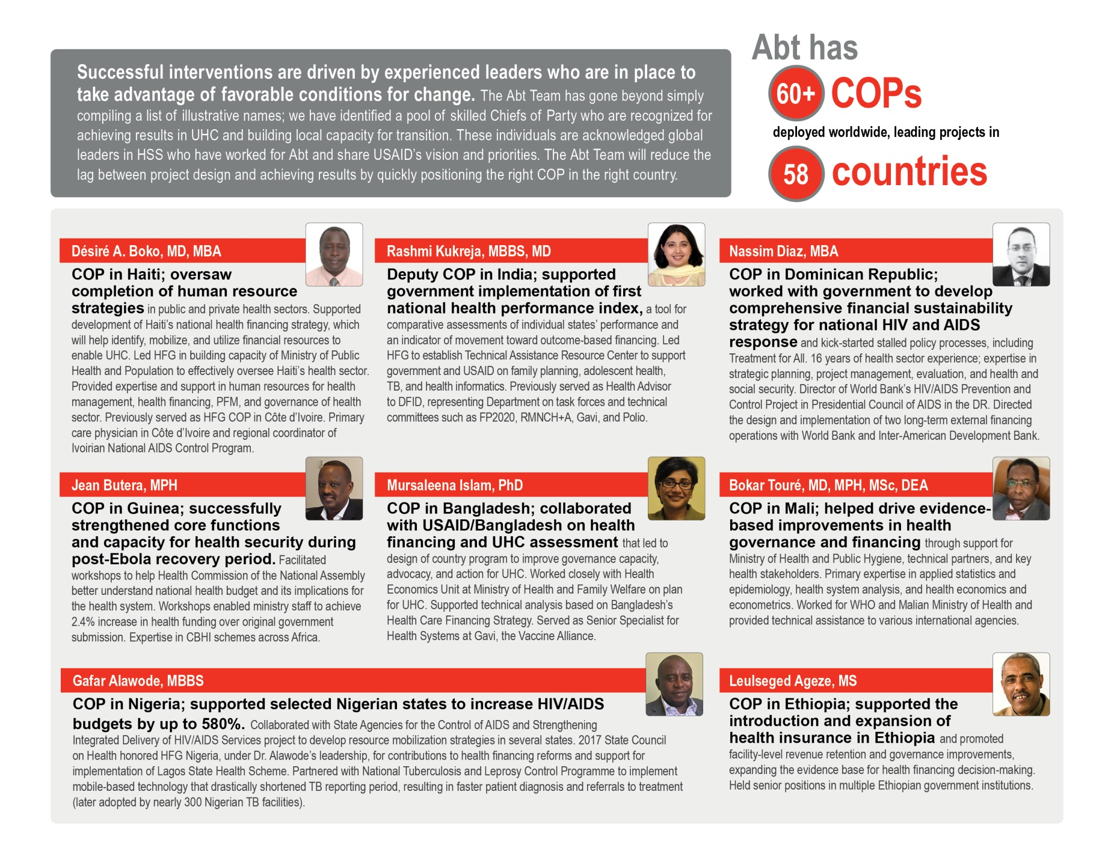

Exhibit 28: Abt Team Matrix of Illustrative Staff Skills

| **Staff or Consultant Name** | **Partner** | **Background** | | | **Health Financing** | | | | | **Health Governance** | | | **Health Systems and Sustainability** | | | | | **Quality Improvement** | | | | **MERL** | | | **Regional Expertise** | | | |
| --- | --- | --- | --- | --- | --- | --- | --- | --- | --- | --- | --- | --- | --- | --- | --- | --- | --- | --- | --- | --- | --- | --- | --- | --- | --- | --- | --- | --- |
|  |  | **US. TCN, or LCN** | **Relevant Yrs. Experience** | **Highest Degree Obtained** | **DRM and PFM** | **PPPs and innovative financing** | **Purchasing and payments** | **Pooling and insurance** | **Private Providers** | **Health policy and planning** | **Civil society and the media** | **Accountability** | **Gender and social inclusion** | **Technical capacity building** | **E-health, HIS, digital health** | **Procurement / supply chain** | **Community health systems** | **OD and financial management** | **Health workforce** | **National QI strategy** | **Clinical guidelines** | **M&E, Research and learning** | **Knowledge management** | **Africa** | **Asia** | **Europe & Eurasia** | **LAC** | **Middle East** |
| **Cali, Jonathan** | **Abt** | **US** | **7** | **MA** | ⚫ | ⚫ |  |  |  | ⚫ |  |  |  |  |  | ⚫ |  | ⚫ |  |  |  |  | ⚫ | ⚫ | ⚫ |  | ⚫ |  |
| **Faye, Sophie** | **Abt** | **US** | **7** | **PhD** | ⚫ |  | ⚫ |  |  | ⚫ |  |  |  | ⚫ |  |  |  | ⚫ |  |  |  | ⚫ | ⚫ | ⚫ |  |  |  |  |
| **Greene, Kate** | **Abt** | **US** | **13** | **MA** |  |  |  |  |  | ⚫ |  |  |  |  |  |  | ⚫ | ⚫ | ⚫ | ⚫ |  |  |  |  |  |  |  |  |
| **Johns, Ben** | **Abt** | **US** | **16** | **PhD** | ⚫ |  |  |  |  |  |  |  |  |  |  |  |  |  |  |  |  | ⚫ |  | ⚫ | ⚫ | ⚫ | ⚫ |  |
| **Laird, Kelley** | **Abt** | **US** | **14** | **MA** |  | ⚫ | ⚫ |  |  | ⚫ |  | ⚫ | ⚫ | ⚫ |  |  | ⚫ | ⚫ |  | ⚫ |  |  | ⚫ | ⚫ | ⚫ |  |  |  |
| **Strizrep, Tihomir** | **Abt** | **TCN** | **23** | **MD** |  | ⚫ | ⚫ | ⚫ |  |  |  |  |  |  | ⚫ |  |  |  |  |  |  | ⚫ |  | ⚫ | ⚫ | ⚫ |  |  |
| **White, James** | **Abt** | **TCN** | **17** | **MSc** |  | ⚫ |  |  | ⚫ | ⚫ |  |  |  | ⚫ |  |  | ⚫ |  | ⚫ | ⚫ | ⚫ | ⚫ |  | ⚫ |  |  | ⚫ |  |
| **Forsythe, Steven** | **Avenir** | **US** | **28** | **PhD** | ⚫ | ⚫ | ⚫ |  |  | ⚫ |  |  |  | ⚫ |  |  |  | ⚫ |  |  |  |  | ⚫ | ⚫ | ⚫ | ⚫ | ⚫ | ⚫ |
| **Winfrey, William** | **Avenir** | **US** | **24** | **PhD** | ⚫ |  |  | ⚫ |  | ⚫ |  |  |  |  |  |  |  |  |  |  |  |  |  | ⚫ | ⚫ |  |  | ⚫ |
| **Cabrera, Enrique** | **Banyan** | **TCN** | **10** | **MA** | ⚫ | ⚫ | ⚫ |  | ⚫ | ⚫ |  |  | ⚫ | ⚫ |  |  |  | ⚫ |  |  |  | ⚫ | ⚫ | ⚫ |  |  | ⚫ |  |
| **Estevez, Ignacio** | **Banyan** | **US** | **26** | **MA** | ⚫ | ⚫ |  |  | ⚫ |  |  |  | ⚫ | ⚫ |  |  |  | ⚫ |  |  |  | ⚫ |  | ⚫ | ⚫ | ⚫ | ⚫ |  |
| **Kruk, Margaret** | **Harvard** | **US** | **20** | **PhD** |  |  |  |  |  | ⚫ |  |  |  |  |  |  | ⚫ |  |  |  |  | ⚫ |  | ⚫ | ⚫ |  |  |  |
| **Abdulwahab, Ahmad** | **HISP** | **LCN** | **21** | **MA** | ⚫ | ⚫ | ⚫ |  |  | ⚫ |  | ⚫ | ⚫ | ⚫ | ⚫ |  | ⚫ | ⚫ |  | ⚫ | ⚫ |  | ⚫ | ⚫ |  |  |  |  |
| **Hedberg, Calle** | **HISP** | **TCN** | **20** | **MA** |  |  |  |  |  | ⚫ |  |  |  | ⚫ | ⚫ |  |  | ⚫ |  |  |  |  | ⚫ | ⚫ | ⚫ |  |  |  |
| **Ngomane, Nhanhla** | **HISP** | **LCN** | **17** | **MA** | ⚫ |  |  |  |  | ⚫ |  | ⚫ | ⚫ | ⚫ | ⚫ |  |  | ⚫ |  |  |  |  | ⚫ | ⚫ | ● |  |  |  |
| **Broomhead, Sean** | **HISP** | **LCN** | **14** | **MD** | ⚫ |  |  | ● | ● | ⚫ |  | ⚫ | ● |  | ⚫ | ● | ⚫ |  | ● |  | ⚫ | ● | ⚫ | ⚫ |  | ⚫ |  |  |
| **Shaw, Vincent** | **HISP** | **LCN** | **27** | **PhD** | ⚫ | ⚫ | ⚫ | ● | ● | ⚫ |  |  | ● | ⚫ | ⚫ | ● | ⚫ | ⚫ | ● | ⚫ | ⚫ | ⚫ |  | ⚫ | ⚫ |  |  |  |
| **Don Berwick** | **IHI** | **US** | **35** | **MD** |  | ● | ● | ● | ● | ● | ● | ● | ● | ● | ● | ● | ● | ● | ● | ● | ● | ● | ● | ● | ● | ● | ● | ● |
| **Arrieta, Jafet** | **IHI** | **TCN** | **7** | **PhD** |  | ⚫ | ⚫ | ⚫ | ● | ● |  |  | ● | ⚫ |  |  | ● | ⚫ | ● | ⚫ |  | ● | ⚫ |  |  |  | ● |  |
| **Barker, Pierre** | **IHI** | **US** | **25** | **MD** | ⚫ | ⚫ | ⚫ | ⚫ |  | ⚫ |  | ⚫ | ⚫ | ⚫ |  |  | ⚫ | ⚫ | ● | ⚫ | ⚫ | ● | ⚫ | ⚫ | ⚫ | ⚫ | ⚫ | ⚫ |
| **Hema Magge** | **IHI** | **US** | **13** | **MD** |  |  |  |  |  | ● |  |  | ● | ● | ● | ● | ● | ● | ● | ● | ● | ● | ● | ● |  |  |  |  |
| **Lyons, Joyce** | **Initiatives** | **US** | **25** | **PhD** |  |  |  |  |  |  |  |  |  | ⚫ |  |  | ⚫ | ⚫ |  | ⚫ |  |  |  | ⚫ | ⚫ |  |  | ⚫ |
| **Campbell, Alison** | **Internews** | **US** | **25** | **BA** |  |  |  |  |  |  | ⚫ | ⚫ | ⚫ | ⚫ |  |  |  | ⚫ |  |  |  | ⚫ | ⚫ | ⚫ | ⚫ | ⚫ | ⚫ |  |
| **Jayaram, Kartik** | **McKinsey** | **TCN** | **18** | **MA** | ⚫ | ⚫ |  | ⚫ | ⚫ | ⚫ |  |  |  | ⚫ | ⚫ | ⚫ |  |  |  |  |  |  |  | ⚫ | ⚫ |  |  | ⚫ |
| **Atim, Chris** | **R4D** | **LCN** | **20** | **PhD** | ⚫ |  | ⚫ | ⚫ |  | ⚫ |  |  |  |  |  |  |  | ⚫ |  |  |  |  |  | ⚫ | ⚫ |  |  |  |
| **Cashin, Cheryl** | **R4D** | **US** | **20** | **PhD** | ⚫ |  | ⚫ |  |  | ⚫ |  |  |  |  |  |  |  | ⚫ |  |  |  |  | ⚫ | ⚫ | ⚫ | ⚫ |  |  |
| **Heller, Nathaniel** | **R4D** | **US** | **20** | **MA** |  |  |  | ⚫ |  |  |  | ⚫ |  |  |  |  |  | ⚫ |  |  |  |  |  | ⚫ | ⚫ |  |  |  |
| **Makinen, Marty** | **R4D** | **US** | **40** | **PhD** | ⚫ |  | ⚫ |  |  | ⚫ |  |  |  |  |  |  |  | ⚫ |  |  |  |  | ⚫ | ⚫ | ⚫ | ⚫ | ⚫ | ⚫ |
| **Tolmie, Courtney** | **R4D** | **US** | **10** | **MA** |  |  |  |  |  |  |  | ⚫ |  |  |  |  |  | ⚫ |  |  |  |  |  | ⚫ |  |  |  |  |
| **George, Joby** | **SC** | **TCN** | **19** | **MHA** |  |  |  |  | ● | ⚫ |  | ⚫ |  | ⚫ | ⚫ |  | ⚫ |  | ● | ⚫ | ⚫ | ● | ⚫ | ⚫ | ⚫ |  |  |  |
| **Mannan, Ishtiaq** | **SC** | **TCN** | **23** | **MSc** | ⚫ | ⚫ | ⚫ |  | ● | ⚫ |  | ⚫ |  | ⚫ | ⚫ |  | ⚫ | ⚫ | ● | ⚫ | ⚫ | ● | ⚫ |  | ⚫ |  |  |  |
| **Snetro, Gail** | **SC** | **US** | **30** | **MA** | ⚫ |  | ⚫ |  |  | ⚫ |  | ⚫ | ⚫ | ⚫ |  |  | ⚫ | ⚫ |  | ⚫ |  |  | ⚫ | ⚫ | ● |  | ● |  |
| **Joseph de Graft-Johnson** | **SC** | **US** | **27** | **DrPH** |  |  |  |  |  | ● |  | ● |  | ● | ● |  | ● |  |  | ● | ● | ● | ● | ● | ● |  |  |  |
| **Vaz, Lara** | **SC** | **US** | **25** | **PhD** |  |  |  |  | ● | ● |  | ● | ● | ● | ● |  | ● |  |  | ● | ● | ● | ● | ● | ● |  | ● |  |
| **Bouey, Paul** | **SC** | **US** | **25** | **PhD** |  |  |  |  |  | ● |  | ● |  | ● | ● |  | ● |  |  |  |  | ● | ● | ● | ● |  |  |  |
| **Cristobal, Fortunato** | **THEnet** | **TCN** | **40** | **MD** |  |  |  |  |  |  |  | ⚫ |  | ⚫ |  |  | ⚫ |  | ⚫ |  | ⚫ |  |  |  | ⚫ |  |  |  |
| **Iputo, Jehu** | **THEnet** | **LCN** | **30** | **PhD** |  |  |  |  |  |  |  | ⚫ |  | ⚫ | ⚫ |  | ⚫ |  | ⚫ | ⚫ | ⚫ |  | ⚫ | ⚫ |  |  |  |  |
| **Palsdottir, Bjorg** | **THEnet** | **TCN** | **19** | **MA** |  |  |  |  |  | ⚫ |  | ⚫ |  | ⚫ |  |  |  |  | ⚫ |  |  |  | ⚫ | ⚫ |  | ⚫ |  |  |
| **Middleton, Lyn** | **THEnet** | **TCN** | **28** | **PhD** |  |  |  |  |  | ⚫ |  | ⚫ |  | ⚫ |  |  | ⚫ |  | ⚫ |  | ⚫ | ⚫ |  | ⚫ |  |  |  |  |
| **Frelick, Graeme** | **TRG** | **US** | **31** | **MA** | ⚫ |  |  |  |  |  |  | ⚫ |  | ⚫ |  |  |  | ⚫ |  |  |  | ⚫ | ⚫ | ⚫ | ⚫ | ⚫ | ⚫ | ⚫ |
| **Lumumba, Jawara** | **TRG** | **US** | **31** | **MD** |  |  |  |  |  | ⚫ |  | ⚫ |  | ⚫ |  |  |  | ⚫ |  |  |  | ⚫ | ⚫ | ⚫ | ⚫ | ⚫ | ⚫ |  |
| **Rosensweig, Fred** | **TRG** | **US** | **38** | **MA** | ⚫ |  | ⚫ |  |  | ⚫ |  | ⚫ | ⚫ | ⚫ | ⚫ |  | ⚫ | ⚫ |  | ⚫ |  | ⚫ | ⚫ | ⚫ | ⚫ | ⚫ | ⚫ | ⚫ |

Annex 2: Organizational Chart

Exhibit 29: Abt Team Organizational Structure: Country-Led Implementation

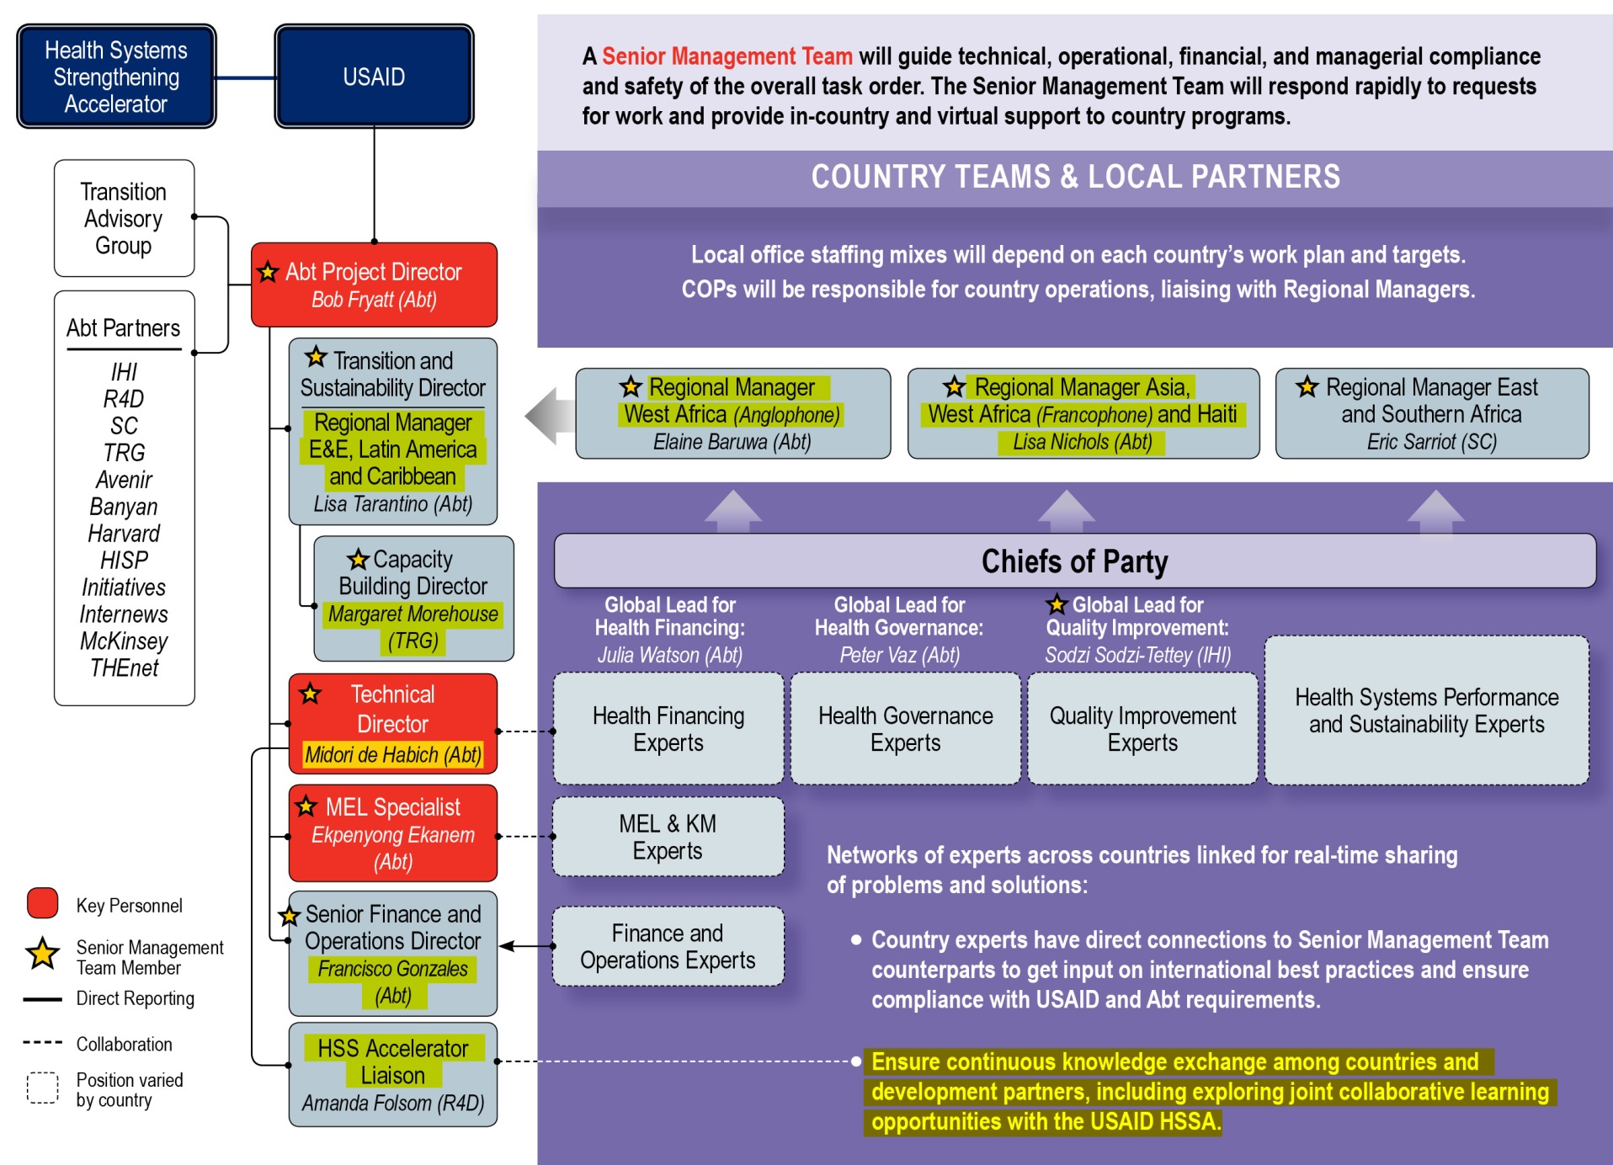

Annex 3: Key Personnel CVs/Resumes and Signed Statements of Commitment

|  |  |
| --- | --- |
| Project Director | |
| BOB FRYATT  MD, MPH, MBBS | * Renowned public health expert * Proven ability to help countries increase their self-reliance and achieve UHC goals * Experienced director of complex multi-country health systems strengthening projects |



**Dr. Bob Fryatt** is a Principal Associate and Scientist with Abt’s International Development Division. In this role, he leads Abt’s health financing and systems reform efforts across the globe, supporting donors and governments in their work toward increasing self-reliance and achieving UHC goals. Dr. Fryatt has more than 25 years of experience as a public health and social policy expert in LMICs. He has held leadership and policy advisory roles in governments, donors, multilateral agencies, and NGOs in Asia, Africa, the U.S., and Europe—including nine years of direct implementation experience while living in South Africa, India, and Nepal.

Dr. Fryatt recently served as Project Director ofHFG, a five-year, $209-million global health project led by Abt and funded by USAID. As director of this flagship HSS project, Dr. Fryatt was responsible for providing overall strategic direction, liaising with USAID and partner country governments, guiding field implementation in more than 40 countries, and ensuring that lessons learned informed policy and practice around the world. Prior to joining Abt, Dr. Fryatt was an independent public health specialist and advisor to several international agencies, including the World Bank, WHO, Global Fund, DFID, and Government of Australia. He also worked with the Government of South Africa, supporting ambitious reforms to tackle major health problems facing the country, including HIV and tuberculosis (TB).

Dr. Fryatt is a renowned thought leader in health systems strengthening, public sector financing reform, and health governance. He has published widely on issues relating directly to UHC, including health economics, access to medicines, public-private partnerships, and national health policy. Dr. Fryatt has a Medical Doctorate with a specialization in the economic evaluation of TB programs and a Master’s in Public Health.



* Medical Doctorate, University of London
* Master’s in Public Health Medicine, London School of Tropical Medicine and Hygiene
* Diploma in Tropical Medicine and Hygiene, Royal College of Physicians
* Medical Degree (MBBS), Westminster Medical School, London University
* Fellow of the UK Faculty of Public Health, awarded 2003 (membership since 1994)
* Membership of the UK Royal College of Physicians



Botswana, Ethiopia, Haiti, India, Indonesia, Malawi, Nepal, Nigeria, Papua New Guinea, Saudi Arabia, South Africa, Syria, United Kingdom



*Project Director, Health Finance and Governance (HFG) Project,* Abt Associates

2016–2018 | ROCKVILLE, MD

* Provided strategic leadership for the project, guided field implementation in more than 40 countries, and oversaw more than 80 headquarter staff and more than 120 field staff.
* Worked closely with USAID and partners in Haiti, Ethiopia, India, and Nigeria to help local organizations (public service providers, private sector, and NGOs) undertake reforms for health services to better focus on achieving UHC goals.
* Built productive relationships between HFG/USAID and multilateral institutions (e.g., WHO, Global Fund, World Bank) to augment the quality and impact of HFG’s work.
* Introduced and led a global knowledge and learning strategy to ensure HFG’s lessons learned and best practices were widely disseminated to inform future policy and practice.

Public Health and Health Systems Specialist, Independent Consultant

2013–2015 | MULTIPLE COUNTRIES

* ***Syria:*** Led the development of a DFID health strategy to re-orientate the humanitarian response and better protect and improve health in the context of a chronic conflict.
* ***South Africa:*** Conducted a mid-term review of USAID’s MEASURE Evaluation Strategic Information for South Africa project; facilitated a National Department of Health (NDOH)/Treasury workshop on National Health Insurance; served as technical adviser for primary health “Ideal Clinics” initiative; supported district health systems strategy; co-authored papers on National Health Insurance with the Director-General; and prepared papers and presented on options for “Innovative financing for health” in South Africa.
* ***Papua New Guinea:*** Served as Team Lead for the Australian Department of Foreign Affairs and Trade (DFAT) independent evaluation of Health and HIV Partnership project.
* ***Indonesia:*** Served as Team Lead for DFAT to design the Strengthening Health Evaluation and Research in Indonesia project.
* ***World Bank Health, Nutrition and Population Global Practice:*** Advised on the start-up of a Global Financing Facility for reproductive, maternal, newborn, and child health (RMNCH); prepared a global scale-up plan for strengthening civil registration and vital statistics.
* ***World Bank, WHO, and USAID:*** Lead author of Roadmap on Measurement and Accountability for Health for the World Bank, WHO, and USAID Summit in June 2015.

Senior Health Adviser, National Department of Health, Government of South Africa, DFID

*2009–2013 | SOUTH AFRICA*

* Resident senior advisor responsible for managing DFID’s £50 million, five-year technical support program to address priority health issues facing South Africa, notably HIV and TB.
* Worked closely with NDOH Director-General to support ambitious system-wide reforms related to National Health Insurance, including reforms in financial management, compliance with health standards, and results-based primary health care service delivery.
* Helped re-engineer primary health care through the new “Ideal Clinics” initiative; facilitated national coordination and set-up mechanisms for dialogue and analysis.
* Worked with mining sector on TB, the mobile phone industry on scaling up m-health, and South Africa’s National AIDS Council to strengthen capacity and improve accountability.

Senior Health Advisor, DFID Southern Africa Regional Millennium Development Goal (MDG) Team

*2011–2013 | SOUTH AFRICA*

* Served as a member of DFID Southern Africa Senior Management Team.
* Supervised preparation and implementation of DFID’s regional program on prevention of gender-based violence, including a consultation with the Government of South Africa.
* Led the regional MDG team, ensuring the quality of business cases, economic appraisals, and management designs for health, social development, and governance projects.
* Oversaw a multi-method impact assessment of DFID’s support for governance reforms.

Coordinator, High-Level Taskforce on Innovative Financing for Health Systems, WHO

*2007–2009 | SWITZERLAND*

* Set up, managed, and coordinated the High-Level Taskforce on “Innovative Financing for Health Systems” in collaboration with World Bank and the UK Prime Minister. Reviewed financing initiatives and prepared the final report for the UN General Assembly.

Strategic Planning and General Management Advisor, WHO

*2005–2007 | SWITZERLAND*

* Completed WHO’s Ten-Year Vision for its general program of work. Secured commitment to it from within WHO prior to its approval by 192 nations at the World Health Assembly. Worked on six-year Strategic Plan and facilitated management review of WHO in Africa.
* Established and led the International Health Partnership with the World Bank, working with multilateral, bilateral, and NGO stakeholders, and focusing on aid effectiveness for health in LMICs. The partnership has now evolved into the IHP+ UHC2030 initiative, covering more than 50 countries with the aim of UHC by 2030.

Policy Adviser, Department of Country Focus, WHO

*2001–2005**| SWITZERLAND*

* Led the design of a strategy to improve WHO’s performance in LMICs. Prepared country guidance on Sector-wide Approaches, the Global Fund, and Aid Effectiveness. Worked with the WHO Assistant Director-General for Health Systems and Services to establish a new cluster of WHO global programs to strengthen the performance of national health systems.

Head of Health Sector Group and Senior Health Adviser, DFID

1998–2001 | INDIA

* Led a multi-disciplinary team to develop and evaluate DFID programs covering HIV/AIDS, TB, reproductive health, and health systems reform. Managed the transition from DFID financing of discrete projects to supporting national programs and state health sectors in collaboration with World Bank, EC, UN, and national institutions.

Health Systems and Institutional Development Adviser, DFID

*1996–1997 | UNITED KINGDOM*

* Advised on institutional/systems aspects of new models of service delivery for HIV/AIDS, setting up new contractual relationships between the state, NGOs, and private providers.

Research Fellow, Health Policy Unit, London School of Tropical Medicine and Hygiene

*1995–1996**| UNITED KINGDOM*

* Completed Medical Doctorate thesis on cost-effectiveness of TB treatment in Nepal.

Public Health Physician, North Thames Region, National Health Service

*1991–1994 | UNITED KINGDOM*

* Completed post-graduate training in North London, working on district public health with rural, urban, and inner-city populations, including linking PHC and public health.

District Health, Britain-Nepal Medical Trust

*1988–1991 | NEPAL*

* Managed local staff teams in two remote hill districts, working on TB and leprosy control and essential drug programs. Led integration of NGO services within PHC systems. Established and evaluated new district essential drug supply program and led professional development programs for government paramedical workers and traditional healers.

Health Care Delivery Physician, National Health Service

*1982–1988**| UNITED KINGDOM*

* Delivered emergency medicine and gastroenterology in teaching hospitals in West London. Provided clinical teaching programs and set-up an interdisciplinary group for AIDS. Practiced medicine in accident and emergency, pediatrics, general medicine, and tropical medicine.



Fryatt, R.J. and Bhuwanee, K. “Financing health systems to achieve the health Sustainable Development Goals.” *Lancet Global Health* Vol.5: Number 9. Sept. 2017, e841-e842.

Fryatt R.J., Bennett, S., and Soucat, A. “Health sector governance: should we be investing more?” *BMJ Global Health* 2017; 2:e000343. doi:10.1136/bmjgh-2017-000343.

Matsoso M.P., Fryatt, R.J. and Andrews, G. (eds). *The South Africa Health Reforms: 2009–2014. Moving towards Universal Health Coverage.* Juta: 2015.

Fryatt, R.J. **“**Primary health care and international development assistance.” Contribution to book *International perspectives to primary care research.* Editors F. Goodyear-Smith and Bob Mash. CRC Press: 2015.

Fryatt, R.J., Hunter, J., and Matsoso, M.P. “Innovations in primary health care: What are the opportunities for South Africa under the National Health Insurance?” *South African Health Review*. November 2014.

Kula, N. and Fryatt, R.J. “Public and private interactions on health in South Africa: What are the opportunities?” *Health Policy and Planning* 2013; 1–10. doi:10.1093/heapol/czt042.

Fryatt, R.J. and Mills, A. “Taskforce for International Innovative Financing for Health Systems: showing the way forward.” *Bulletin of the World Health Organization.* 2010; 88:1–3, doi:10.2471/BLT.09.075507.



* **Jeanette R. Hunter:** Deputy Director-General, Primary Health Care, Republic of South Africa Department of Health, (012) 395 9652, [huntej@health.gov.za](mailto:huntej@health.gov.za)
* **David H. Peters:** Edgar Berman Professor and Chair, Bloomberg School of Public Health, Johns Hopkins University, (410) 502-5364, [dpeters@jhsph.edu](mailto:dpeters@jhsph.edu)
* **Dr. Neil Squires:** Director of Global Public Health, Public Health England, +44 (0) 113 8557237, [neil.squires@phe.gov.uk](mailto:neil.squires@phe.gov.uk)

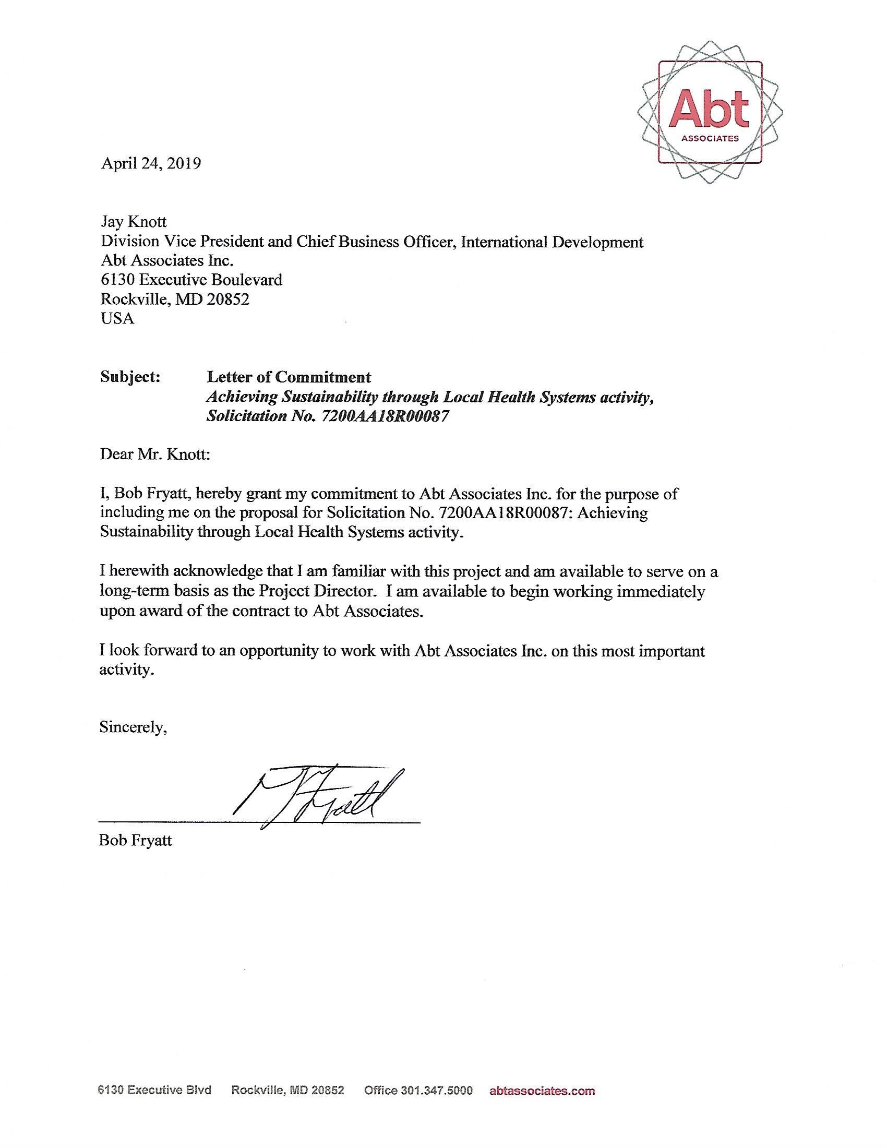

|  |  |
| --- | --- |
| Technical Director | |
| MIDORI de HABICH  MA | * Dynamic and renowned global HSS expert * Former Minister of Health with demonstrated expertise in improving population coverage and expanding quality service coverage * Experienced (more than 12 years), LMIC-based program leader |



Abt is pleased to propose Ms. Midori de Habich as Technical Director for TO1. Ms. de Habich brings twenty-five years of experience leading and implementing development activities in LMIC, including two years serving as Minister of Health, and ten years as Chief of Party of USAID-funded projects in her native country of Peru.

Ms. de Habich has extensive demonstrated experience operating within the global HSS community on matters related to HSS in LMIC countries, including serving as Co-Chair of the World Health Organization Universal Health Coverage (WHO-UHC) 2030 sustainability, transition from external aid and health system strengthening technical working group, and a member of the WHO Health Financing Group where she contributed to development of a framework for political economy analysis for health financing reform and country case studies. A recognized expert in financial protection and population coverage, she is a highly sought after speaker at global HSS events such as the multi-stakeholder hearing on UHC that will convene on 29 April, in preparation for the UN General Assembly's (UNGA) High-level Meeting on UHC. Ms. de Habich’s ability to synthesize and apply HSS lessons across countries is further demonstrated by her participation on the WHO High-level Mission to advise the Government of Kenya on UHC and by her work as a Senior Fellow with R4D, where she has advised policymakers from eight LMICs including in the Caribbean, Cote D’Ivoire, Ghana and Kenya on strategies for mobilizing domestic resources for health.

As Minister of Health, Ms. de Habich led comprehensive health reform efforts to extend financial coverage to 15 million citizens. In her ten years as COP for four successive Abt-led and USAID-financed health projects, she made lasting contributions to Peru’s progress towards UHC through her efforts to secure the Political Parties Agreement on Health and the Universal Health Insurance Law and development of tools and methodologies for decentralization and health insurance reform that have been incorporated into government ministries. Ms. De Habich’s work as COP for Project 2000 led directly to the development of Peru’s results-based budgeting framework, primary social protection policies, and the Household Focalization System. Ms. de Habich holds a Master’s Degree in Economic Policy and Planning, a PhD dissertation in progress, and is fluent in English and Spanish.



* PhD, Universidad de Politécnica de Cataluña, Barcelona, Spain, Management. Dissertation in progress.
* MA, Universidad Antonio Ruiz de Montoya, Lima, Peru, Philosophy. In progress.
* MA, Erasmus University Institute of Social Studies, The Netherlands, Economic Policy and Planning.
* BA, Pontificia Universidad Catolica Del Peru, Lima, Economics.



In addition to Peru, Ms. de Habich has advised governments in: Bangladesh, Barbados, Côte d’Ivoire, Ghana, Guyana, Kenya, Tanzania, Trinidad and Tobago, and Suriname. As chair of the South American Council of Health, she worked with and represented Argentina, Bolivia, Brazil, Chile, Colombia, Ecuador, Guyana, Suriname, Uruguay, and Venezuela.



Independent Consultant

2015–present | MULTIPLE COUNTRIES

**Health Reform Consultant, World Health Organization (WHO)**

* **Co-chair, World Health Organization Universal Health Coverage (WHO-UHC) 2030** technical working group (TWG)on sustainability, transition from external aid and health system strengthening.
* **Member, Health Financing Group**. Contributed to development of a framework for political economy analysis for health financing reform and country case studies
* **Member, Global Public Goods TWG.**
* **Team member, High Level Mission** to advise the Government of Kenya on UHC.
* **Keynote speaker, Advanced Course on Health Financing for Universal Coverage for LMICs,** on the use of health financing policy to improve health system performance.
* **Featured speaker, Symposium on Health Financing for UHC,** on health financing policies for UHC at the Fifth Global Symposium on Health Systems Research
* **Senior Fellow, Results for Development (R4D):** Key technical contributor for multi-country workshops for the USAID-funded, Health Finance and Governance (HFG) Project to advise policy makers from eight LMIC countries on strategies to increase domestic resource mobilization, and supported the creation of national action plans.
* **The World Bank:** Member, Steering Committee of 2030 Water Resources Group.
* **Health Reform Consultant, Instituto Peruano de Economía:** Developed a roadmap for universal health protection based on a comprehensive review of Peruvian health sector reform.

**Minister of Health**

2012–2014 | LIMA, PERU

* Led comprehensive health system reform that reorganized the MOH to improve efficiency; extended health insurance coverage to 15 million citizens; established integrated health networks; and instituted a performance-based salary policy for public sector health workers.
* Designed and implemented an investment plan to close infrastructure and service gaps by promoting public-private partnerships, resulting in a 100% increase in health financing.
* Chair of the South American Council of Health, a regional grouping of health ministers to promote common policies and coordinated activities among member countries.
* Featured speaker, PAHO/WHO International Conference: “Towards universal health coverage”.

**Chief of Party, Health Policy Reform Project,** Abt Associates

2010–2012 | LIMA, PERU

* Overall responsibility for technical support for health sector decentralization, and to improve health finance and financial protection through implementation of the Universal Health Law at the local level. The project built capacity of government entities, and local partners in the areas of HRH, health information systems and pharmaceutical and medical supply logistics to sustain health system strengthening work and helped to create policy on to HRH development, medicine and medical supply distribution and financial social protection initiative.

**Chief of Party, Health Systems 20/20 Project,** Abt Associates

2009–2010 | LIMA, PERU

* Coordinated technical assistance to strengthen the health system through policy dialogue, by supporting piloting of decentralization approaches and the design, validation and application of a decentralized M&E system.
* Provided technical assistance for health insurance reform by developing and supporting implementation of tools and methodologies for financial projections and health service delivery information systems, and regional health insurance implementation plans.

**Chief of Party, Promoting Alliances and Strategies (PRAES),** Abt Associates

2005–2009 | LIMA, PERU

* Provided technical support for decentralization and health insurance reform, including the development of technical tools and methodologies that were incorporated into the MOH and Ministry of Economics and Finance (MEF). These include: MED SALUD, a tool for implementation and monitoring and evaluation of the decentralization process; SISFOH, a methodology that targets public subsidies in the Universal Health Insurance and other social programs and is institutionalized within the MEF; ASEGURA that estimates the costs and projects financial requirement for the Essential Health Insurance Benefit Plan (PEAS) and projects staffing requirements to meet UHC goals.
* Led efforts to catalyze political support for policy reform, resulting in a plan to transfer health functions to the Regional Health Directorates; the Political Parties Agreement on Health endorsed by 16 parties; and approval of the Universal Health Insurance Law.

**Chief of Party**, **Partners for Health Reform plus (PHRplus),** Abt Associates

2002–2005 | LIMA, PERU

* Coordinated implementation of a strategy to support technical, political and social components of health reform, including capacity building for health authorities in the use of data for health financing and prioritization and mapping competencies, functions, and responsibilities at each level of the health system.
* Worked with the MOH at the central and regional level, and regional government officials to introduce a participatory planning process for development of Participatory Regional Health Plans (PPRs) that resulted in the popular vote being used to prioritize health concerns for the first time in Peru’s history.
* Contributed to the development of a model, adopted by the GOP, for distributing health functions within the government, including a government accreditation process.

**Project Coordinator,** Project 2000, Development Associates

1995–2002 | LIMA, PERU

* Led the financing development component of Project 2000 that developed tools and methodologies for improving health financing, costing, and budgeting efficiency and effectiveness. These include a decentralized cost-based health programming and budgeting system for 107 provincial units; a cost and inpatient information system for 10 public hospitals; a tariff-based prospective payment mechanism and a decentralized management improvement model for public hospitals
* Conducted research to improve the health sector’s ability to target subsidies and piloted a proxy means-test-based targeting and tariff system. The study was later used to develop Peru’s budgeting-by-results framework, primary social protection policies, and the Household Focalization System to effectively target social assistance.

**Department Chief,** Macroeconomic Indicators, Central Reserve Bank of Peru

1991–1994 | LIMA, PERU

* Conducted research and analysis, and published macroeconomic indicators and economic research papers.

**Economic Analyst and Manager,** Department of Social Studies,Central Reserve Bank of Peru

1984–1989 | LIMA, PERU

* Led research in the following areas: social sector policy, income distribution, poverty maps, poverty measurement, labor markets, and health, education, and food subsidies.



Habich, M. Roadmap for the implementation of health reform in Peru. Inter-American Development Bank. 2016

Habich, M. Advances in the implementation of health reform laws. World Bank. 2015

Habich, M. and M. Madueño. Willingness of medium and high income independent workers to pay for health insurance. ¿Is there demand potential? CIES, Lima 2004.

Project 2000. Cost-based budget programming system: a tool for improving the quality of spending. Ministry of Health, Lima 1999.

Project 2000. Hospital cost and income system: analysis of results. Ministry of Health, Lima 1999.

Project 2000. User identification system: improving equity in the public subsidy. Ministry of Health, Lima 1999.

Project 2000. Hospital management model: results of a pilot. Ministry of Health, Lima 1999.

Project 2000. Health sector financial flows 1994-1995. Ministry of Health, Lima 1997.

Project 2000. Analysis of public expenditure on maternal and child services in 12 regions of

Perú. Ministry of Health, Lima 1996.

Habich, M. Evolution of public spending 1980-1990. Universidad Peruana Cayetano Heredia, Lima 1992.



* Luis Seminario - Ex CTO USAID Perú. +51998492255. [lsemcar@hotmail.com](mailto:lsemcar@hotmail.com)
* Oscar Ugarte - Ex-Minister of Health (only Spanish). +51996680021. [ougarteu@gmail.com](mailto:ougarteu@gmail.com)
* Agnes Soucat. Director of Department of Health Systems, Financing and Governance. WHO. +41 (0)22 791 43 10. [soucata@who.int](mailto:soucata@who.int)

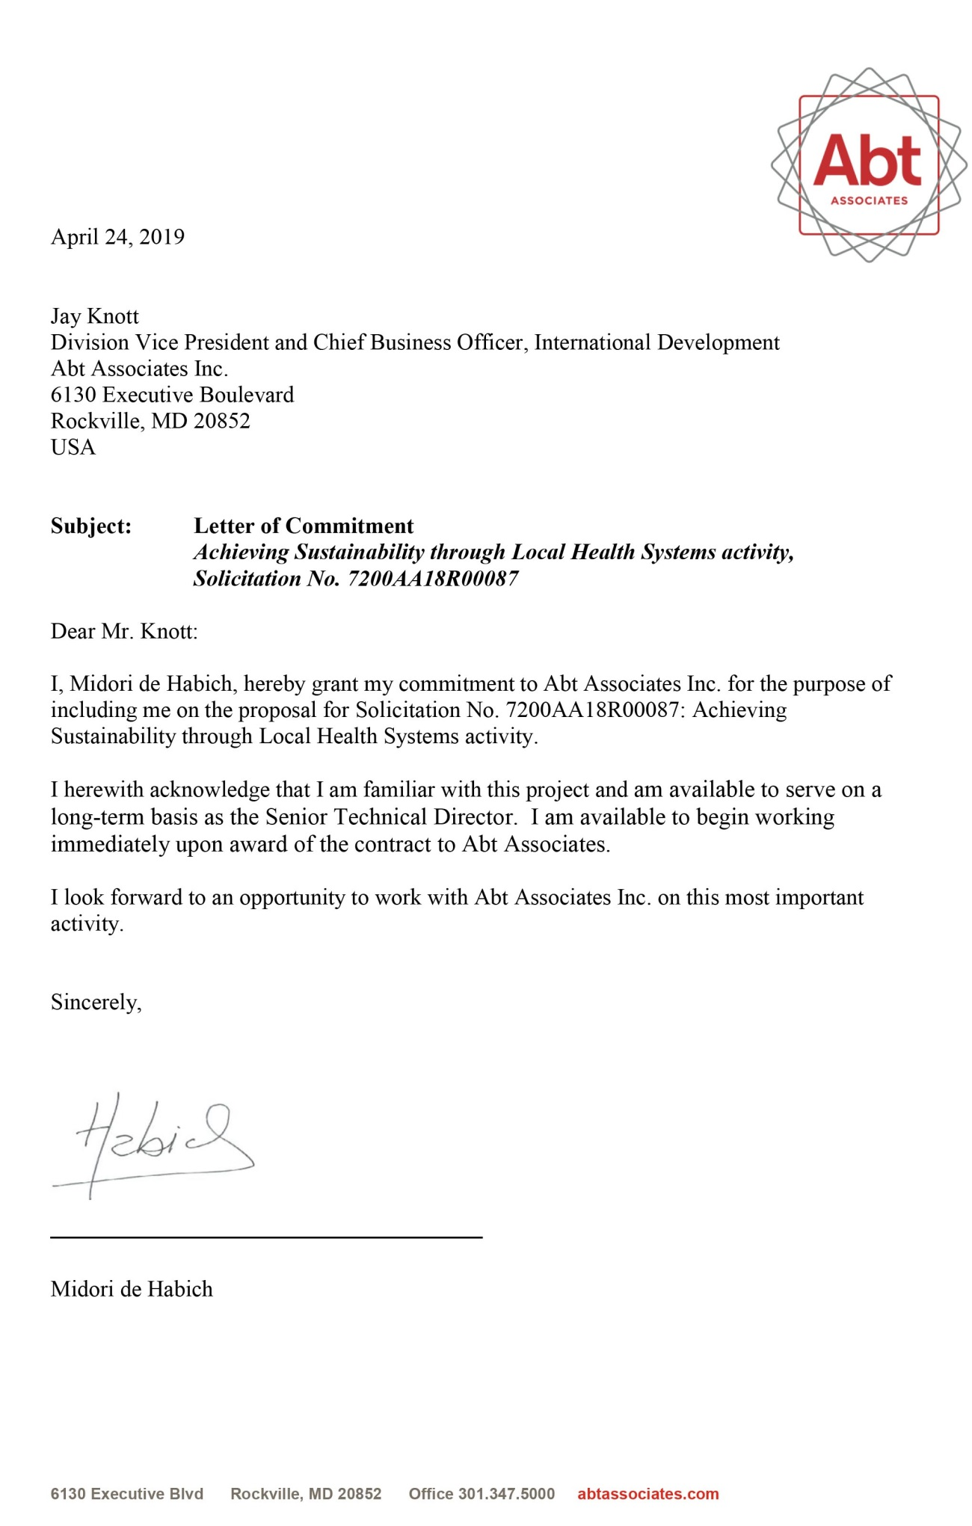

|  |  |
| --- | --- |
| MEL Specialist | |
| EKPENYONG EKANEM  MPH, MBBS | * Skilled HSS professional with 10+ years of MEL leadership and deep understanding of how to apply data and learning to support UHC * Demonstrated expertise in data management and analysis, rigorous study protocols, health system mapping, and translation of data into action |



Dr. Ekpenyong Ekanem has more than nine years of experience *leading and implementing M&E, adaptive management, and learning activities* for public health programs in LMICs. As the M&E Lead and Deputy Country Manager for HFG Nigeria, he supervised and coordinated MEL activities and worked with country and program managers to oversee the collection of quality data and its analysis and translation into actionable information for planning and budgeting. Dr. Ekanem has also served as MEL Specialist in Zambia, Zimbabwe, Nigeria, Tanzania, and South Sudan, where he supervised in-country M&E teams and contributed to strategy development and revisions in response to technical reviews and client demands.

Dr. Ekanem’s expertise in *translating data into actionable information* is illustrated by his work in Nigeria under HFG, where he oversaw the development of a framework for gathering data on the health financing landscape. With a mandate to improve domestic resource mobilization (DRM) for health, he supervised diagnostic assessments and data collection that enabled the project to translate lessons learned into actions that ultimately led USAID to expand the program and quadruple the budget. Dr. Ekanem has *designed rigorous study protocols* for multiple projects. For the SHOPS project in Tanzania, for example, he led revisions to a gender-sensitive protocol for collecting and analyzing data on provision of prevention of mother-to-child transmission (PMTCT) of HIV/AIDS services by private sector associations. His ability to ensure the data was disaggregated not just by sex but also by age helped SHOPS pilot an innovative strategy to use private sector associations to increase service coverage among adolescent mothers and other hard-to-reach groups.

Dr. Ekanem is skilled at *health system mapping and performance assessment*, as shown by his work with USAID to create the Health Systems Benchmarking Tool, a multi-sectoral indicator database that is currently being used by USAID missions, governments, and other donorsin more than 60 LMICs to benchmark and compare health system performance and customize HSS programming. Under the Service Availability and Readiness Assessment (SARA) Activity in Nigeria, he led *quantitative and qualitative data management and analysis* of more than 200 data points in six Nigerian states covering approximately 1,300 PHC facilities. Dr. Ekanem is well-respected in the international donor community through his work with USAID, DFID, BMGF, and the Lucille Packard Foundation. Dr. Ekanem is a native speaker of English, Igbo, and Efik and a skilled written and oral communicator.



* Master of Global Health Leadership/MPH, Concentration in Global Health Policy and Management, New York University, New York, NY
* Primaries in Surgery, West Africa College of Surgeons, Lagos, Nigeria
* MBBS, University of Ibadan, Nigeria



Brazil, Ghana, Nigeria, South Sudan, Tanzania, Zambia, and Zimbabwe



Research, M&E, and Technical Co-lead, Abt Associates International Development Division

2011–PRESENT | ROCKVILLE, MD

*M&E Lead/Deputy Country Manager for Nigeria, USAID-funded HFG Project (2015–Present)*

* Supervised and coordinated implementation of project MEL activities and 14 staff. Developed schedules, plans, goals, and budgets for project activities, independently analyzing lessons learned and results data to reconcile and resolve problems.
* Collaborated with USAID’s Office of Health Systems to build the multi-sectoral Health Systems Benchmarking Tool, which uses built-in analytics to benchmark and compare the performance of health systems across 190 countries and 120 indicator variables.
* As Deputy Country Manager, supported design of rigorous study protocol for health financing diagnostics activity to collect and analyze health finance data in extremely data-poor environment where such information had never before been gathered. Efforts resulted in tripling of USAID funding and expansion from 4 states to 11. As M&E Lead, supervised MEL across 14 staff in 11 states, central project office in Abuja, and home office.
* Led technical work on SARA Activity covering 6 states and over 1,100 facilities, including field work, conceptualization, design, analysis, and QA for this MNCH assessment. Supervised 18 data teams and more than 60 analysts.
* Coordinated preparation, review, and dissemination of analytic reports using qualitative and quantitative data to inform programming adaptations.

M&E Advisor, USAID-funded Zimbabwe Assistance Program in Malaria (ZAPIM) (2016–Present)

* Provides home office M&E oversight to ZAPIM, which supports Zimbabwe’s National Malaria Control Programme (NMCP) with comprehensive malaria prevention and treatment services. Led development of NMCP national M&E plan 2016–2020.
* Contributed to design and fieldwork, and led analysis of national Case-Drug Consumption Study in Zimbabwe to investigate disparities in malaria cases and ACT drug consumption to improve service coverage among hard-to-reach populations.
* Designed multiple survey and data analysis frameworks. Supported baseline and end-line surveys and data analysis, report writing, and quality assurance. Made field visits to supervise M&E on-site, establish and supervise M&E systems, and train four technical staff and 10 survey teams.
* Develops annual project M&E plans during yearly work planning sessions. Manages life-of-project performance monitoring frameworks, including revising project M&E plans to reflect adaptive learning lessons.

M&E and Data Quality Assurance (DQA) Advisor, USAID-funded AIDSFree Zimbabwe PMTCT B+ Activity (2015–2017)

* Provided technical support to two home office and in-country staff to monitor uptake of PMTCT services in about 40 private clinics in three regions in Zimbabwe.
* Supervised in-country M&E specialist and consultant. Supported M&E teams and oversaw DQA for all research and clinical monitoring activities.

M&E and DQA Advisor, USAID-funded SHOPS Tanzania PMTCT B+ Activity (2015)

* Oversaw three home office and in-country health staff to monitor uptake of PMTCT services in 53 private sector clinics across Tanzania. Supervised two M&E staff and oversaw DQA for all research and clinical monitoring activities.

M&E Advisor, USAID-funded South Sudan Health Systems Strengthening Project (2014–2015)

* Provided technical M&E oversight to project with staff of 20. Oversaw 20 staff preparing baseline survey, data analysis, and quality assurance. Developed and managed project monitoring plans, including adaptations.
* Led field visits and M&E on-site supervision, including establishing and supervising M&E systems and training 20 technical staff.

***Technical Project Officer and M&E Specialist, Partnership for the Transformation of Health Systems 2 (PATHS2) Project, Nigeria*** *(2011–2015)*

* Supported updates to logical framework for this DFID-funded project. Supervised M&E across multiple states. After mid-term review, learning gleaned from project data translated into client action to shift project focus from health governance to health service delivery.
* Collaborated with Service Delivery Advisor to develop and maintain QI framework, including developing and managing national survey tools administered to more than 10,000 households, 300 health facilities, and 700 health providers. Designed survey data and analysis framework. Conducted quantitative and qualitative analysis of provider survey, translating the data into actionable information to inform project adaptations and scale up.
* Co-led analysis and reporting for mid- and end-line surveys to inform program adaptation.
* Developed abstracts and disseminated PATHS2 work at conferences and in journals.

Senior Health Systems Analyst, BMGF Primary Health Care Nigeria Investment Case (2014)

* Served as PHC systems analyst as part of core investigator team collaborating with BMGF’s integrated service delivery team to build investment case for support to PHC systems in Nigeria. Co-led development of PHC donor and partner profiles.
* Led field visits to conduct PHC partner landscape assessments, including in-depth development partner and stakeholder interviews and desk reviews of policy documents, national and state level health reports, and other materials. Supervised three in-country consultants conducting national and state-level partner assessments.

M&E Advisor, DFID-funded Scaling Up Family Planning Project Zambia (2012–2013)

* Developed quantitative and qualitative tools for baseline assessment to be administered to 5,000+ households, schools, and facilities. Used NVivo software to analyze qualitative findings from baseline survey.
* Developed logframe indicator reference documents to support M&E framework. Provided home office M&E technical support.

Global Health Affairs Consultant, Global Health Strategies

2011 | NEW YORK, NY

* Provided technical support and clinical perspective to global health issues. Strengthened advocacy, technology development, and communication efforts for organization in Africa.

Public Health Specialist Consultant, Engineers Without Borders

2011 | NEW YORK, NY

* Co-built strategic impact and outcome evaluation framework for rapid assessment of water project in Matunda, Kenya. Laid framework for implementation, which resulted in parallel project elsewhere in Kenya.



American Public Health Association; Health Systems Global; Founder of the Global Public Health Action Network at New York University, 2010-2011



* Reviewer for international medical journals, including *Journal of AIDS and HIV Infections*; International Society of African Bioscientists and Biotechnologists *Journal of Health and Environmental Sciences*.
* Certificate in Principles of Problem-Driven Iterative Adaptation: Building Capability by Delivering Results, Harvard Center for International Development, 2017.
* Educational Council for Foreign Medical Graduates Certification License, U.S., Sept. 2011.



L. Jennings, A. Omoni, A. Akerele, I. Yisa, E. Ekanem. “Disparities in mobile phone access and maternal health service utilization in Nigeria: A population-based survey.” *Int. J. Med. Inform.* (2015)

White, James, Ekpenyong Ekanem, and Leslie Miles. “Delivering an AIDSfree Generation: Extending the Provision of Integrated ANC/PMTCT B+ Services via Private Nurses and Midwives in Tanzania.” Bethesda, MD: SHOPS Project, Abt Associates. June 2015.

Maitra K., A. Aminu, E. Ekanem, M. Egboh. “Institutionalizing Critical Elements of Quality Improvement processes in Resource-poor Settings: Experiences from Nigeria.” Presentation at 142nd Annual Mtg. of the American Public Health Assoc. November 2014, New Orleans.



* **David Gold:** Co-Founder and Chief Executive Officer, Global Health Strategies, (212) 929-7888, M: (917)-669-4400, [dgold@globalhealthstrategies.com](mailto:dgold@globalhealthstrategies.com)
* **Larissa Jennings:** Assistant Professor, Social and Behavioral Interventions, Department of International Health, Johns Hopkins Bloomberg School of Public Health, (410) 955-3537, [ljennin6@jhu.edu](mailto:ljennin6@jhu.edu)
* **John Gershman:** Clinical Professor of Public Service, Co-Director of Capstone Program Faculty, Robert F. Wagner Graduate School of Public Service, New York University, (212) 992 9888, [john.gershman@nyu.edu](mailto:john.gershman@nyu.edu)

